- product B, product C, and product D
- to end on december 3, 2021.
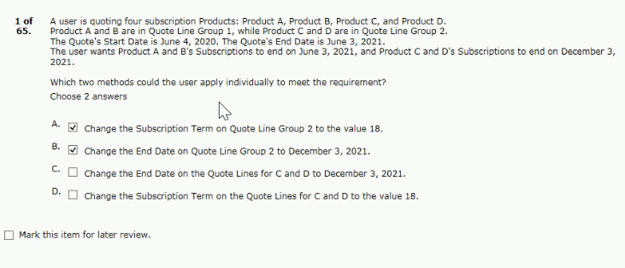
- quote has payment terms of net 30
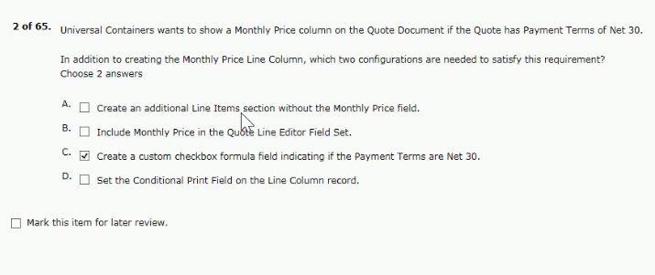
Answer - CD

- import to load price rules into cpq?
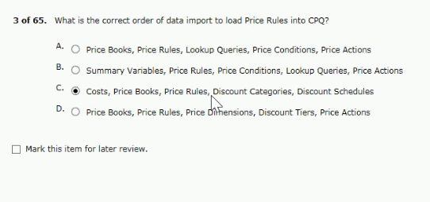
- products to the quota line editor, uc wants
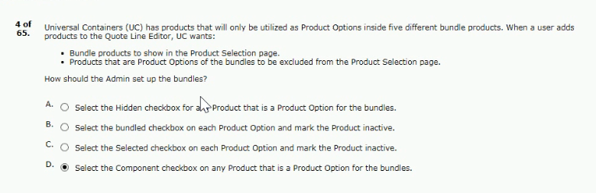
- on quote lines for the renewal quotes
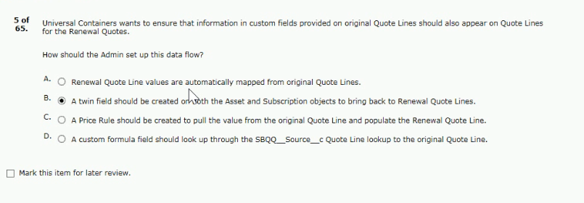

- features in the configurator to be displayed as tabs
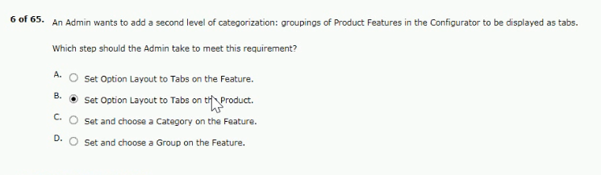
- occur automatically after each change is made
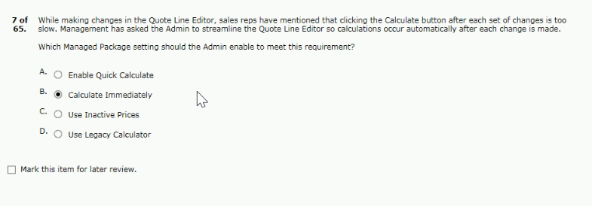

- and its quality than 10, its price falls to $50
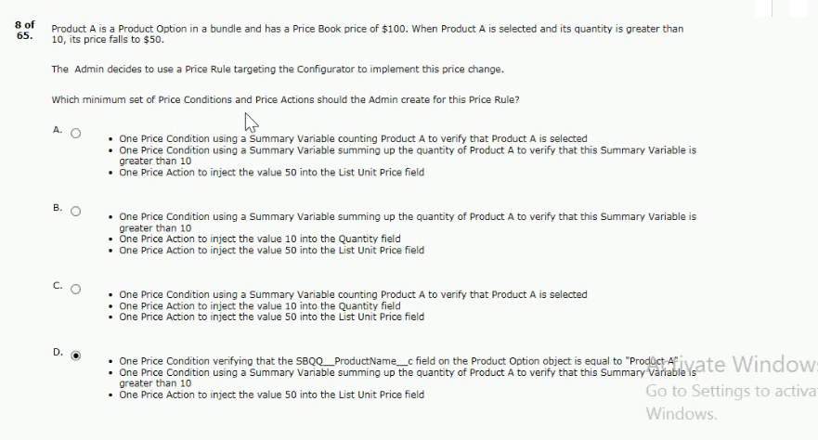
- further discounts on this product are unavailable
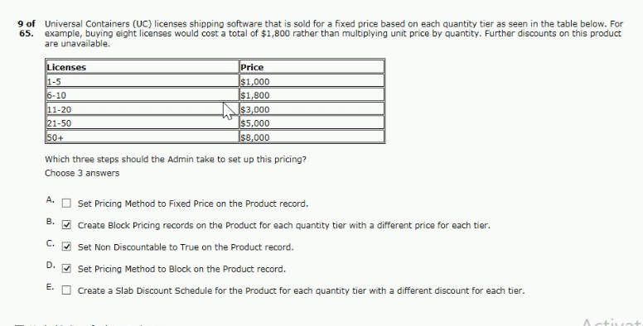

- gaps between anticipated versus actual start dates
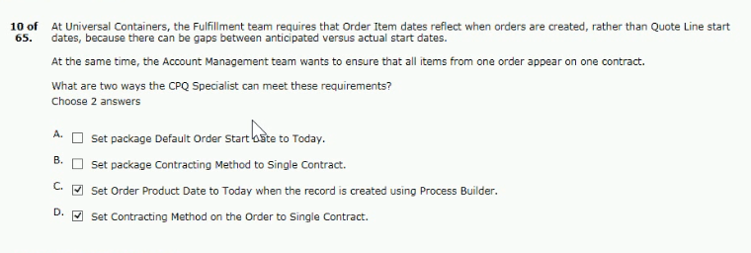
- creating a product rule with an advanced condition
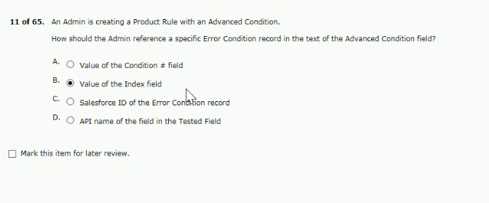
- options share the same discount schedule
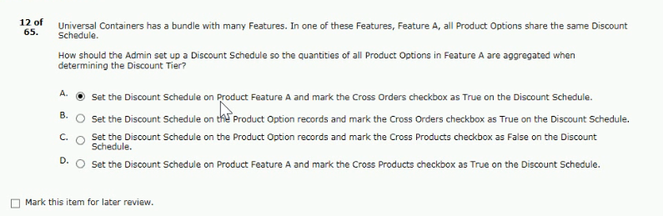

- scrolling to find the desired features and options
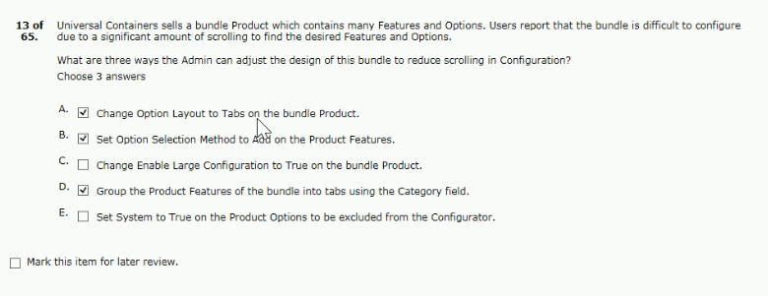
- click calculate twice for the discount to apply.
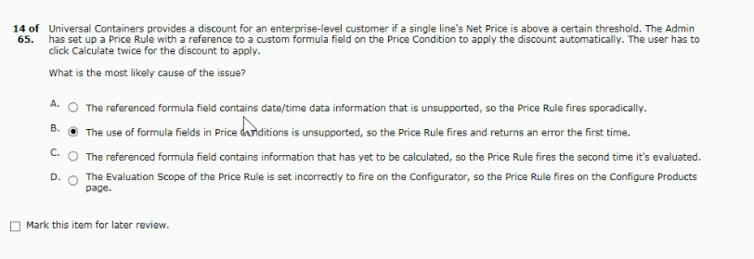

- related to these types of template content
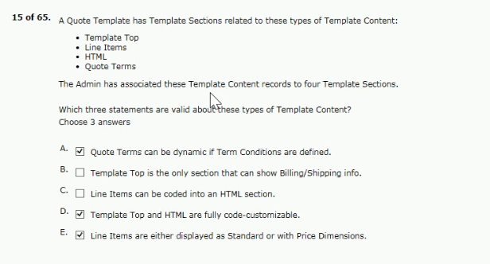
- contains only the original opportunity products
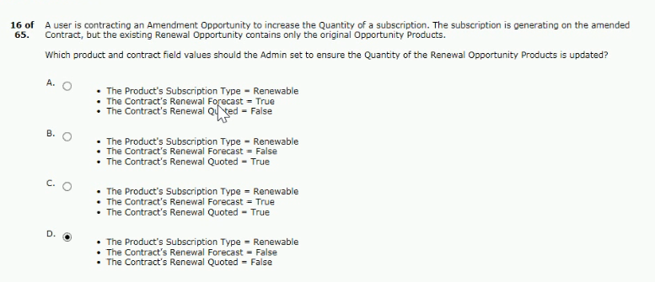

- other fixed-priced products present on a quote
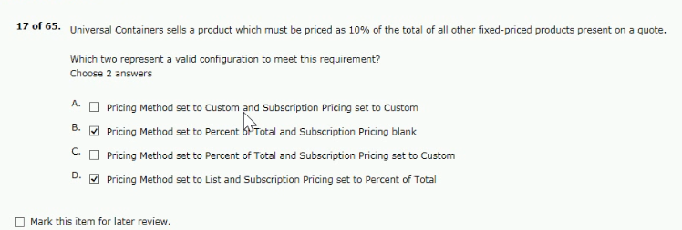
- smart approvals expedite the approval process?
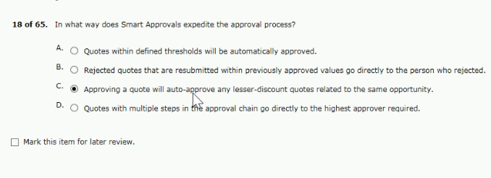
- the quota inherits the price book from the opportunity
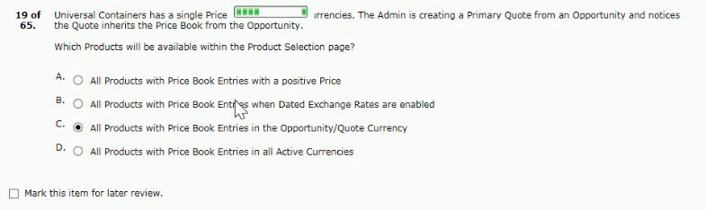

- with values of hardware or software
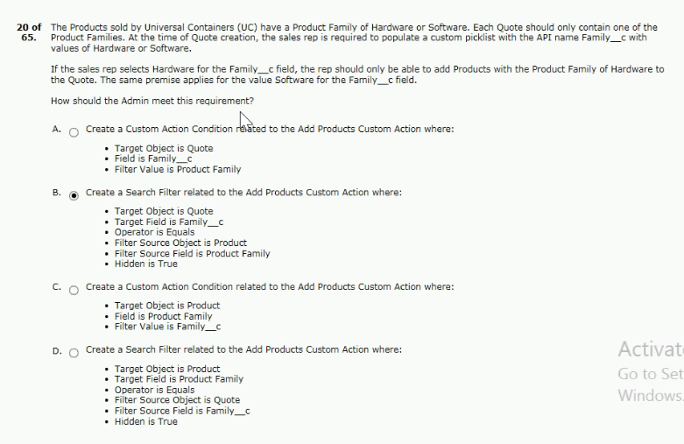
Answer - D (set 3)
- apply on a product-by-product basis for all products
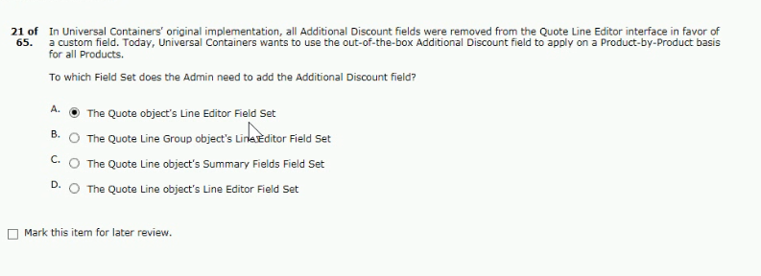

- the price should be included as part of the bundle
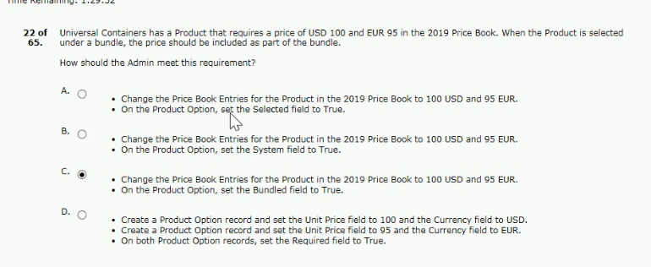
- quote is submitted to reduce the time for quote approval
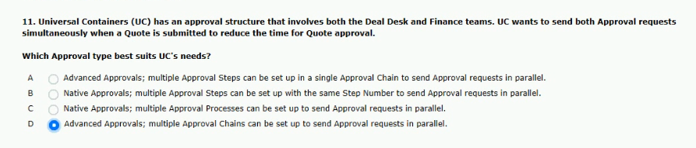

- lines and then the team selects the ordered checkbox
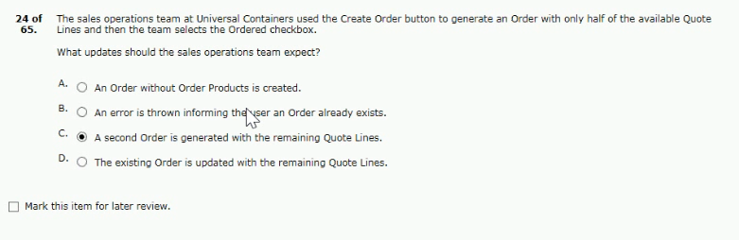
- the prices of products on the configure products page
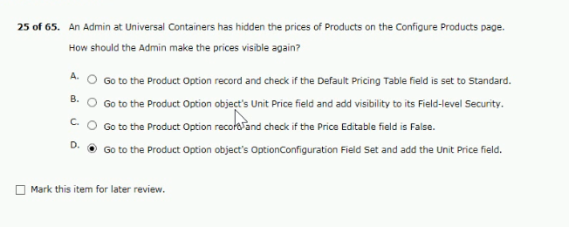
- and a search filter for products flagged as subscription products
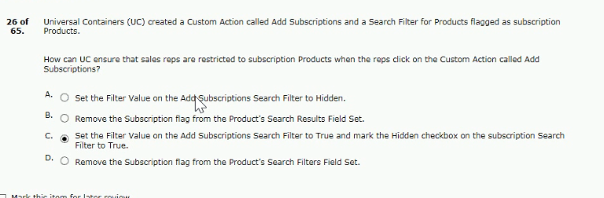
- add-on options without re-configuring the bundle
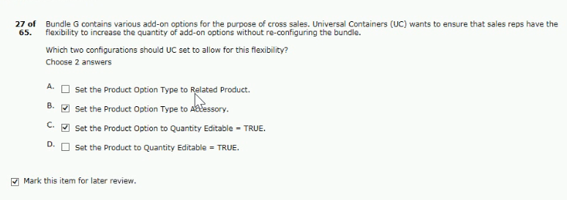

- asset product in addition to another quote line
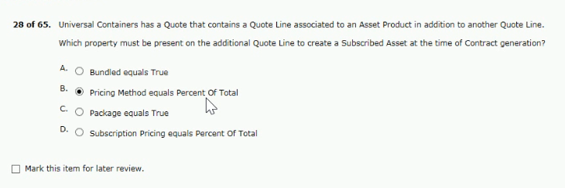
- changes the discount percent of a discount tier, and saves the quote
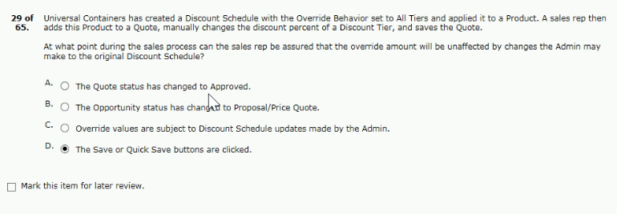

- discount schedule for product a with these discount tiers
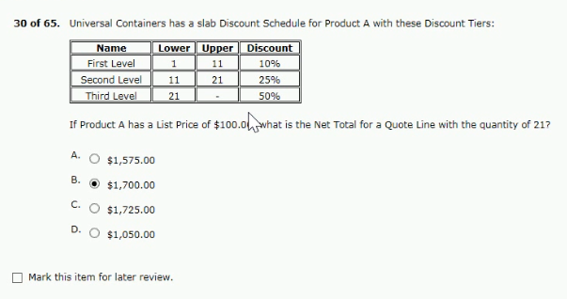
- which characteristic of the quote line editor?
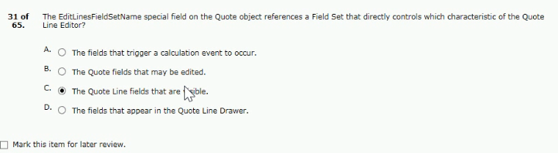
- selected options by scrolling in a single page
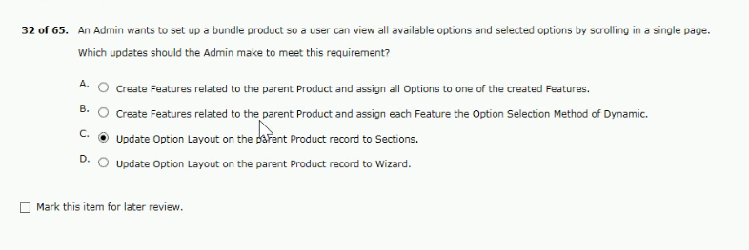
- the custom field still failed to populate
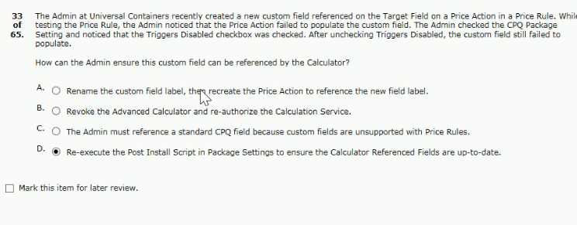
- options are valid for each container size
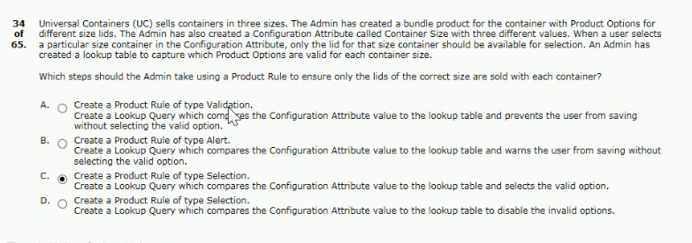
- leverage all advanced approval functionality?
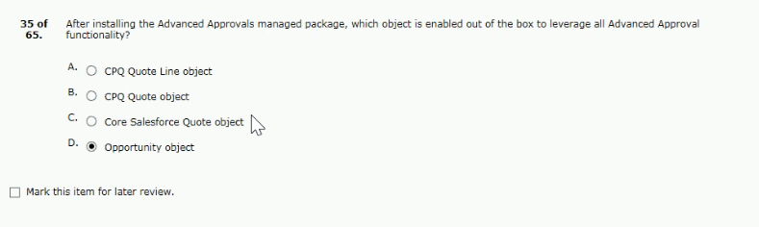

- this item from the product selection screen
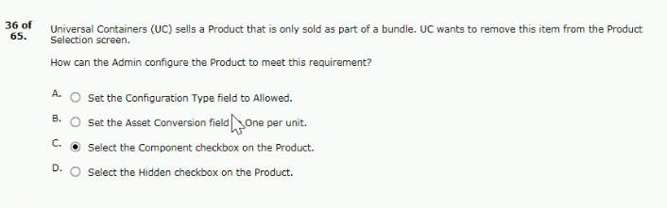
- the user should bypass the configuration process
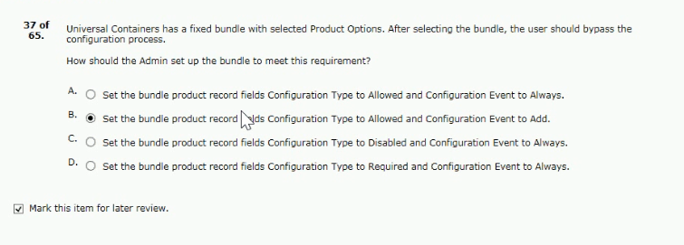
- output documents in microsoft word format?
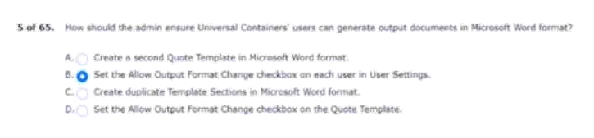

- across all accounts whenever a contract is created
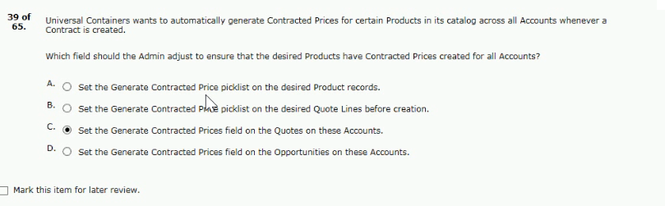
- schedule identifies in a product feature?
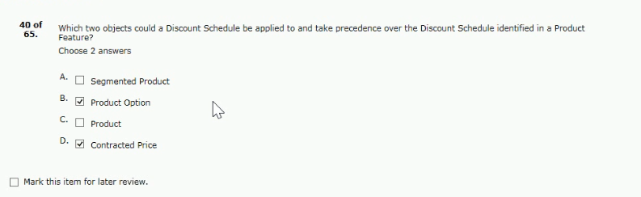
- exists and is located on the quote object
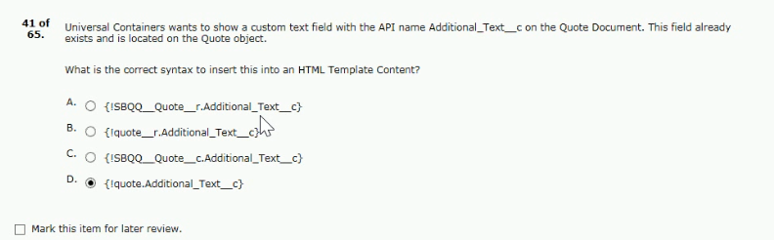

- the two product options from the support feature
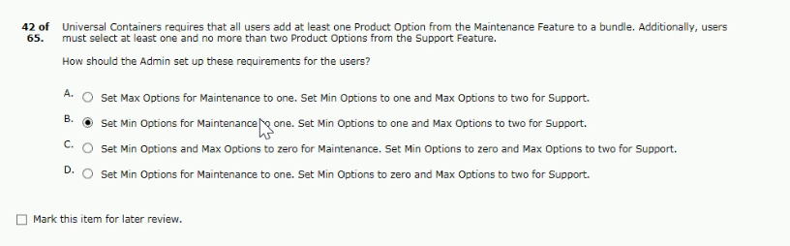
43.and size during configuration
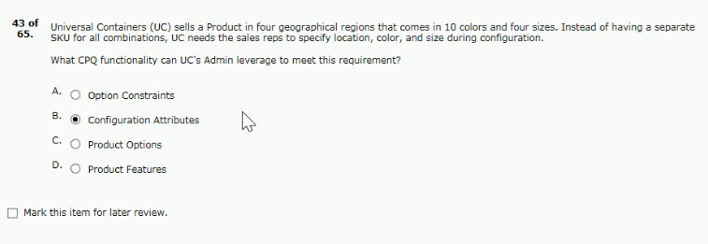
44. the record should go through when submitted
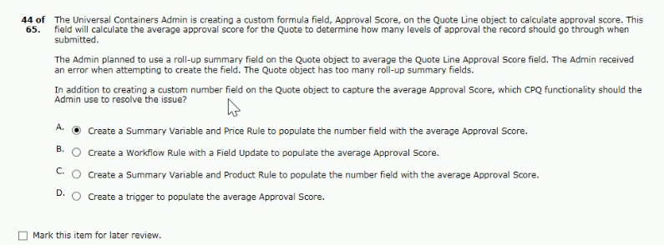

45. populated in the configuration attribute has reverted
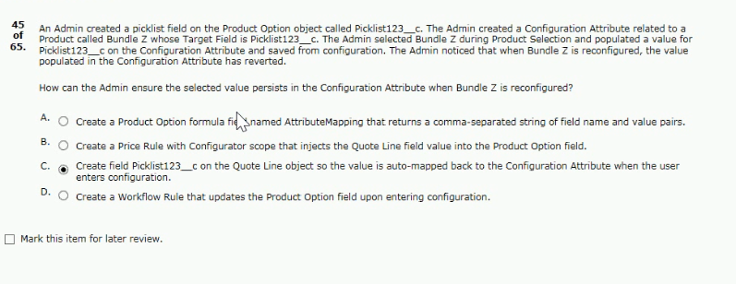
46. groups based on the product family
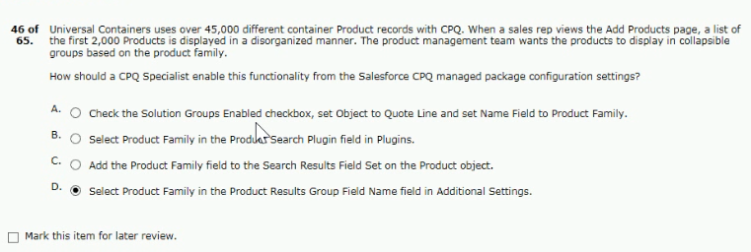
47. define option quantity via bundle configuration
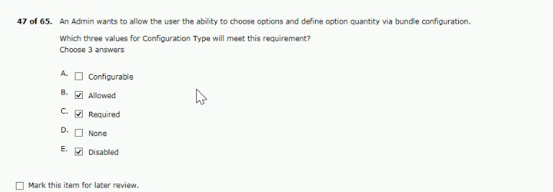

48. containers in the output document
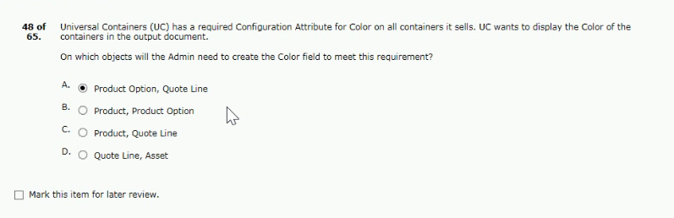
49. structure on the contract is set to true
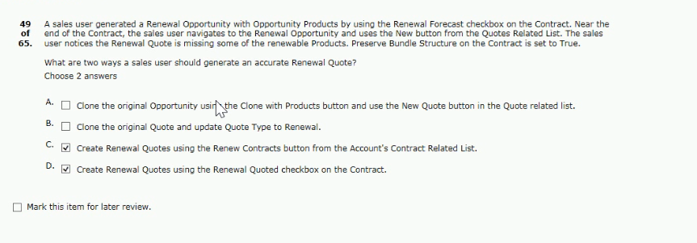
50. product a is an asset product
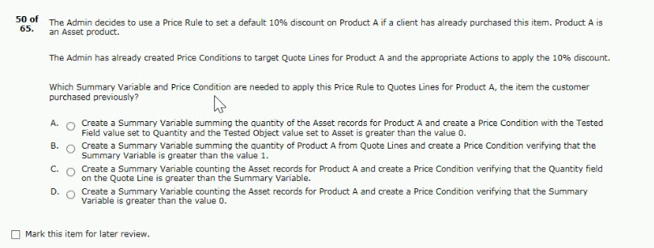
Answer - D
51. for an existing subscription quote line
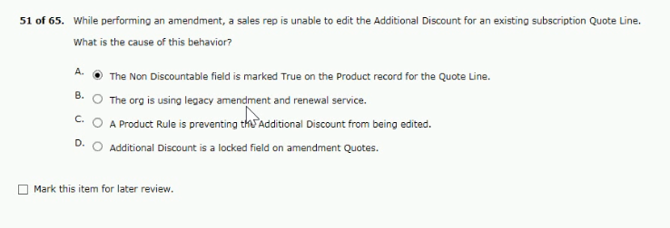
52. users see when configuring the bundle
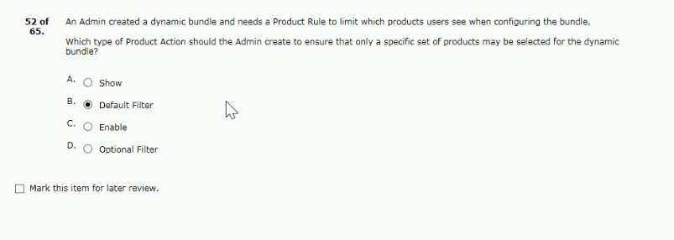
53. discounts for existing active subscription and assets
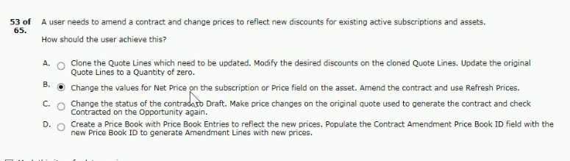

54. apply only for this one specific product
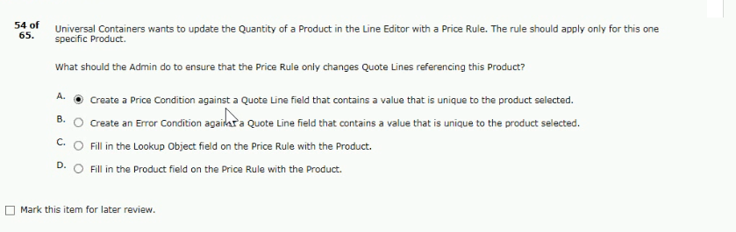
55. to modify the existing contract are made
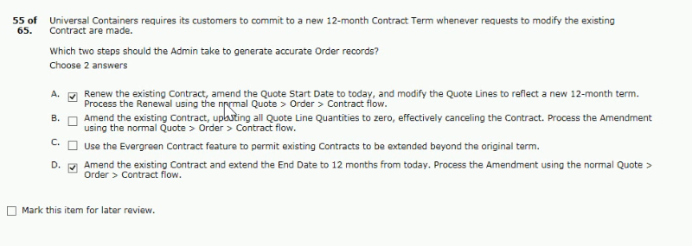
56. when included on quotes that are contracted
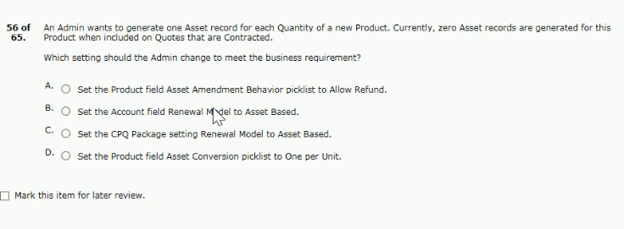
Answer - D

57. multiplied by the quantity of the bundle product
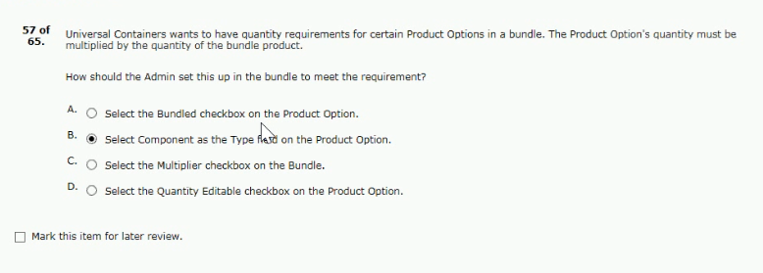
58. options from standard treatments is prohibited
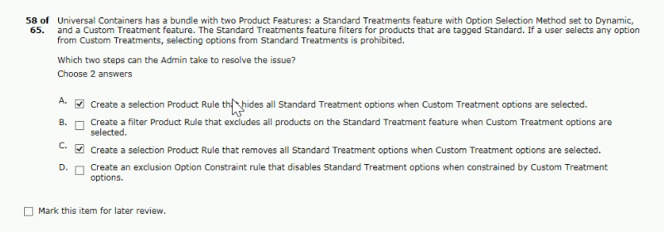
59. created a product rule with a configuration rule
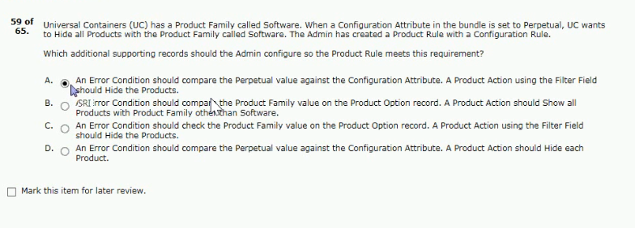

60. overriding the current discount schedule
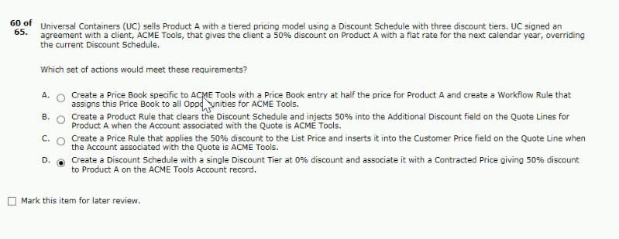
61. select the square footage again on the renewal quote
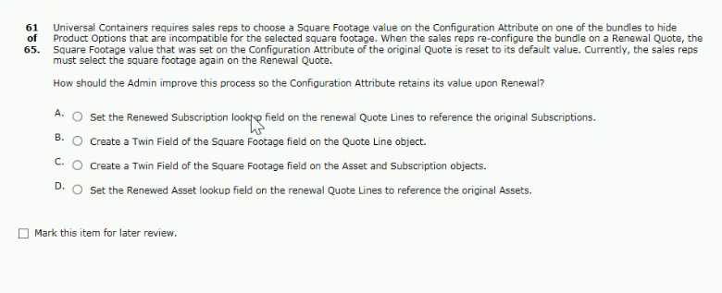
Answer - C

62. tiered pricing for product a on all future quotes
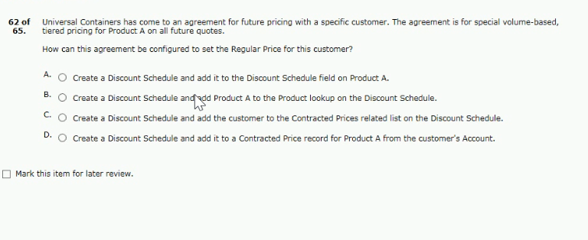
Answer - D
63. record for each downloadable product sold
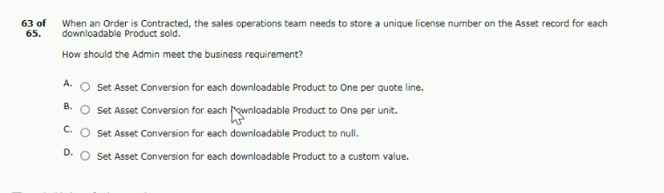
Answer - A

64. regular unit price for the quote line?
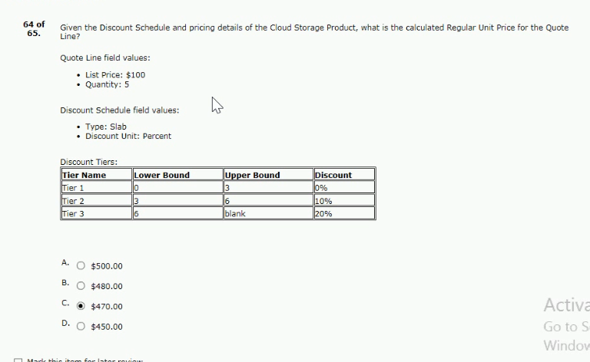
65. specific bundle after initial configuration?
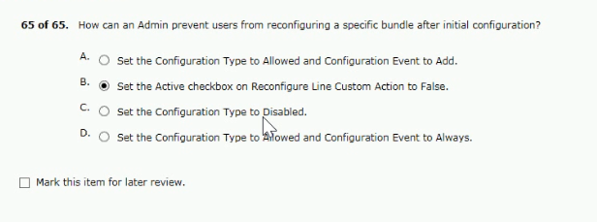

month for calculating the prorated price
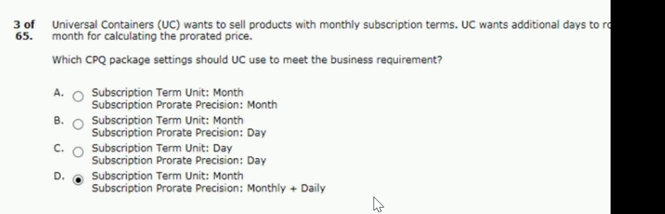
can be supported using amendments?
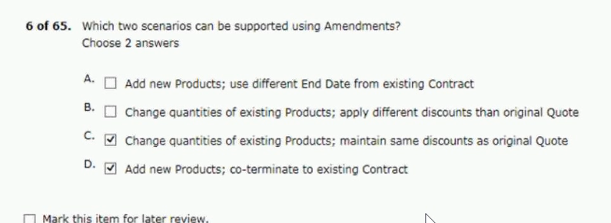
universal containers sends a company pdf brochure with each quote…. sales reps attach.. sent
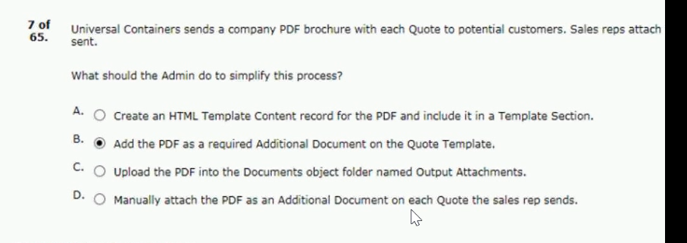

customer has already purchased the product
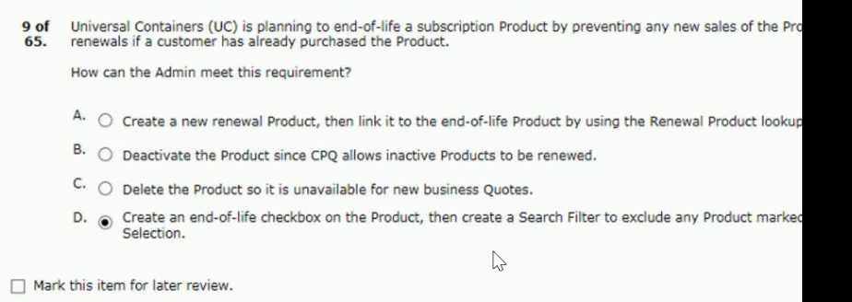
family of the products being ordered
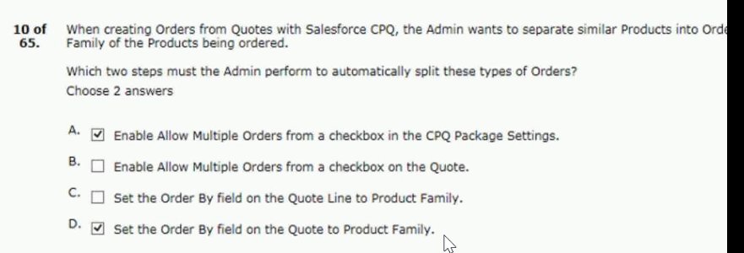
the error message appears before save is clicked
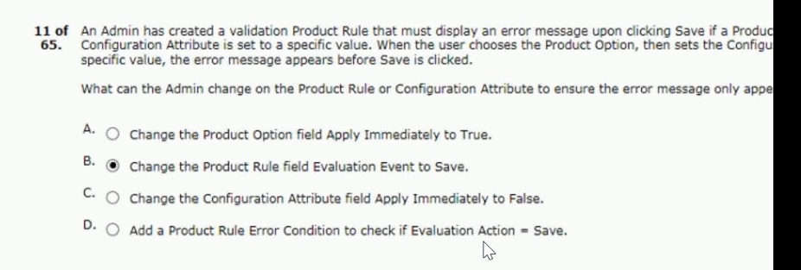

universal containers wants to notify its users when approval is required .. users from discounting .. editor
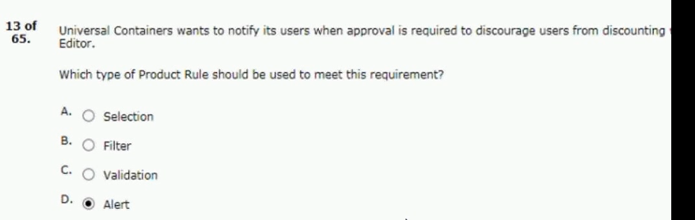
a sales rep notices on opportunities that only some opportunity products.. from quotes.. this disc. in the pipeline
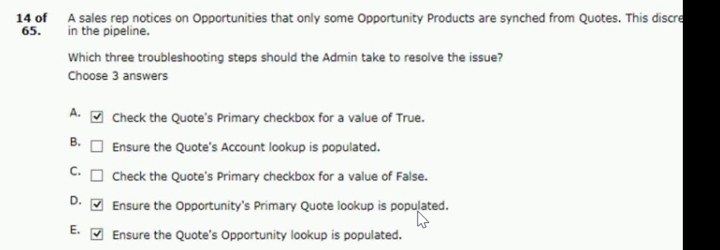
universal containers (uc) wants to organize quoted products representing different project...team to generate a separate on..
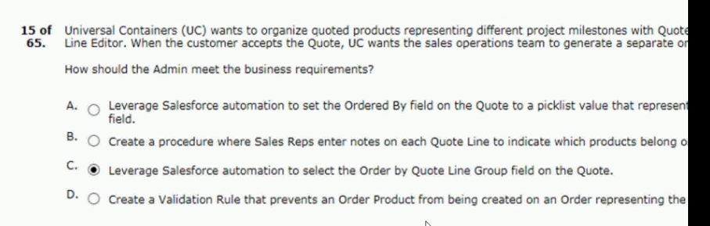

what are two ways salesforce CPQ advanced approval support obtaining approval from a group in a single..
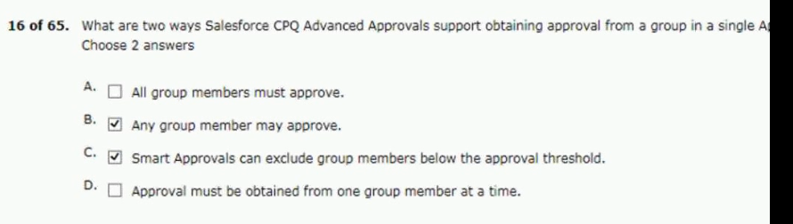
into orders after generation based on the start dates
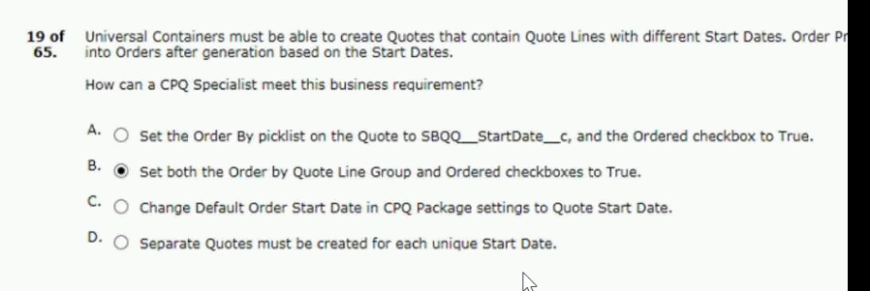
the admin at universal containers wants to add some maintenance and … within the support products displaying all products.
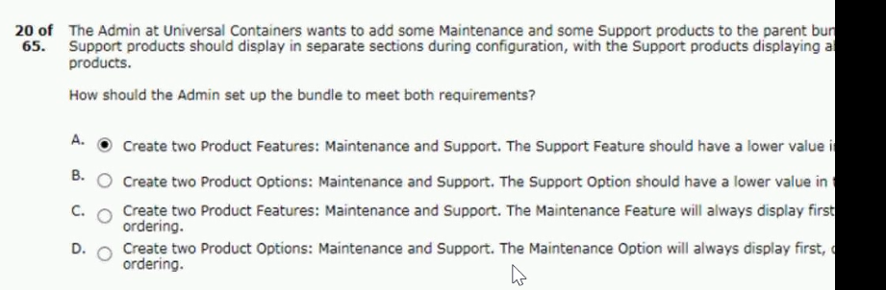

even if the calculated amount fails under$100
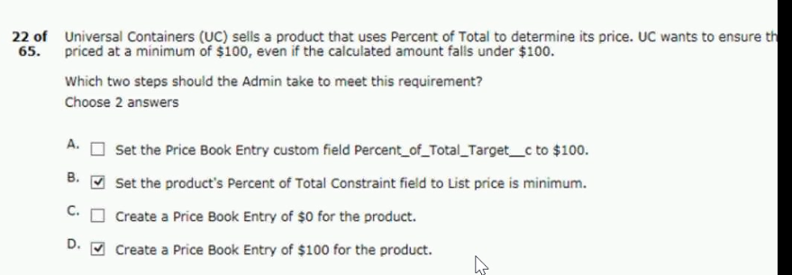
universal containers wants its premier service, shipping plus, to appear at the top of product selection.. quote
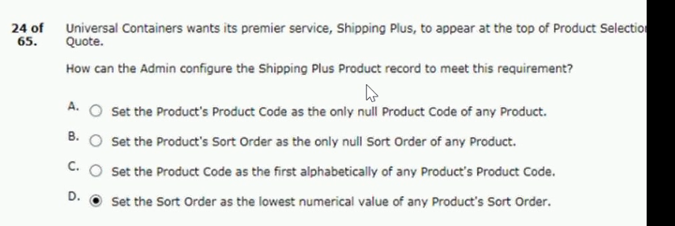
universal containers has four price rules, each with differing calculator evaluation events and evaluation orde..
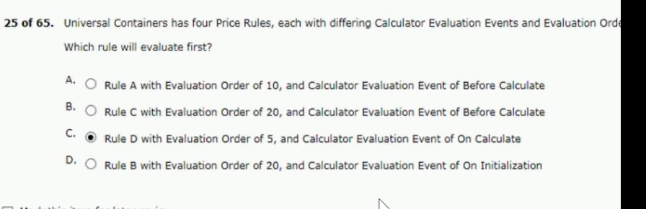

an admin creates a search filter for product code that has a predefined filter value of green and an operation..
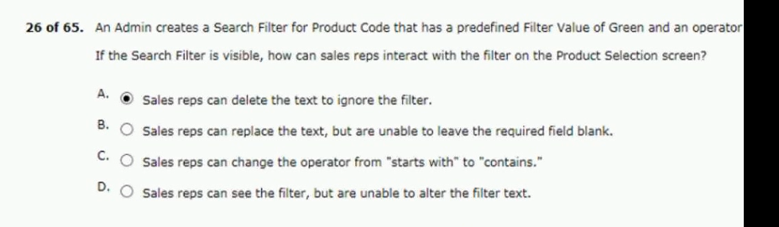
order of data import to load quote template in cpq?
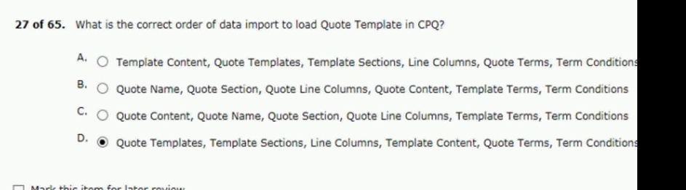
to correctly map between quote lines and product options
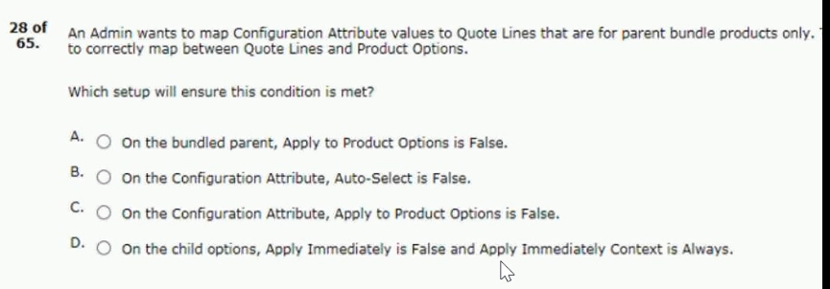
Ans : B

universal containers allows clients to negotiate a discount for product a until a specifies data upon contract activation.
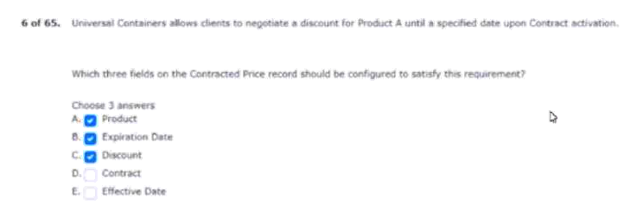

should be based on other options in the same level
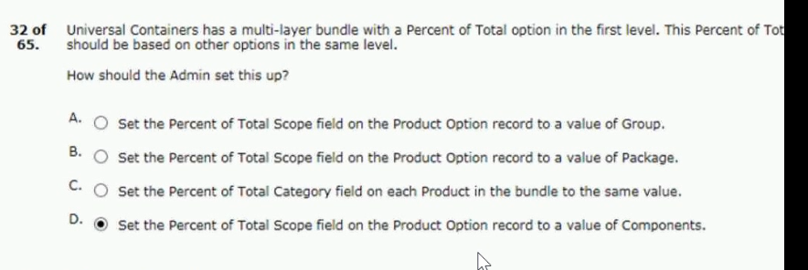
an admin wants to set up a bundle product so a user can view all available options and selected option..
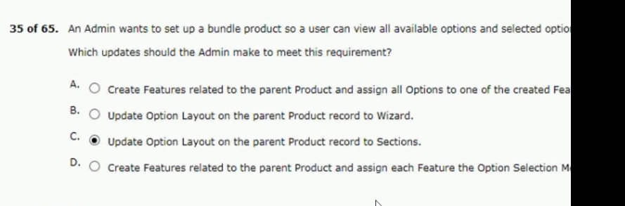

the quantity field on its associated quote line
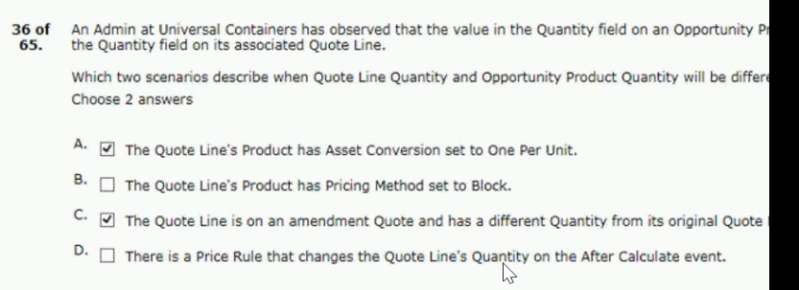
implementing cpq to support two languages
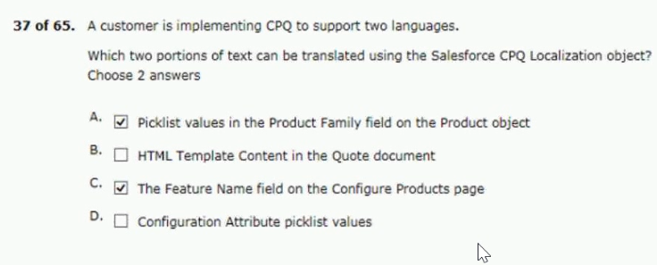
which three cpq pricing functionalities contribute to regular unit price during the price calculation sec..
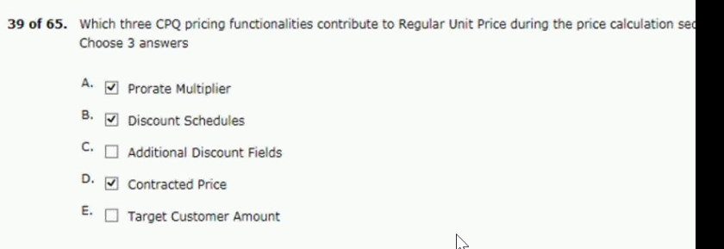

selected must show on the quote line editor with
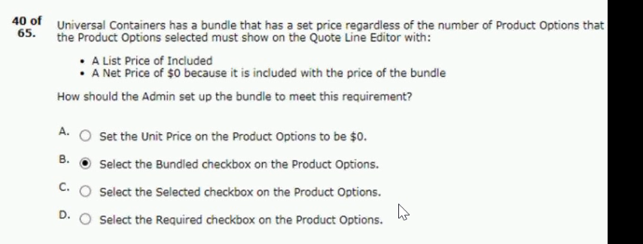
universal containers is rolling out anew version of its premier support offering named premier pro… it is replaced with premium..
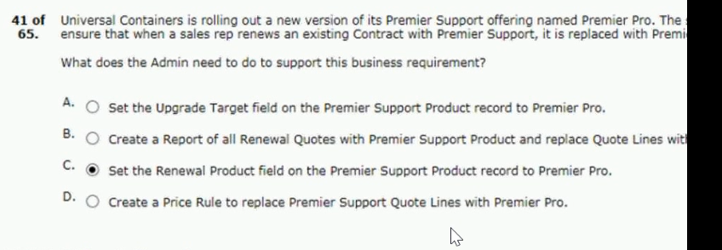
each contract record
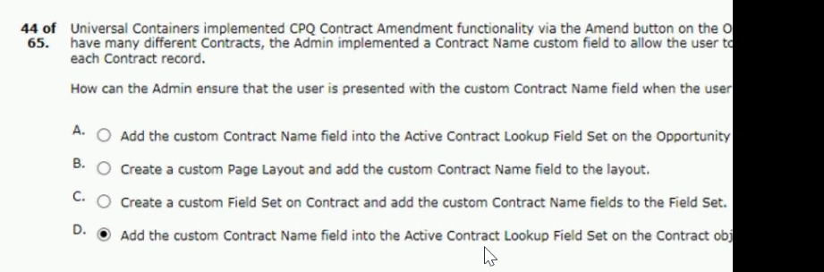
universal containers (uc) sells licenses set up as subscription products...agreed to a quality of 100 license..
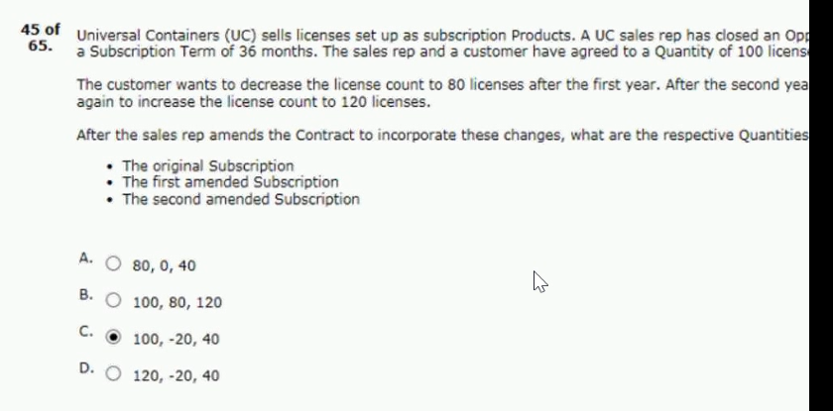
which the original manager is absent?
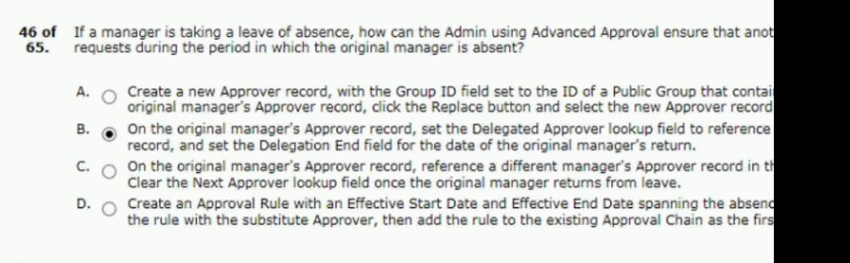

universal containers wants to change its$500 maintenance product to be based on a percentage of sub.. product family.
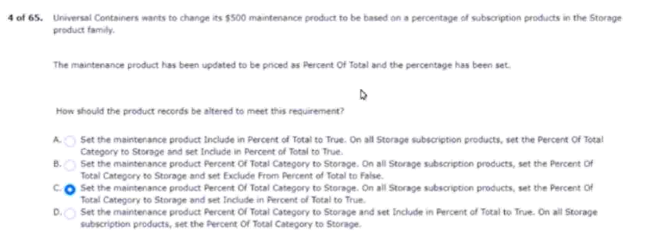

universal containers offers the same products in different regions of the country… through 10
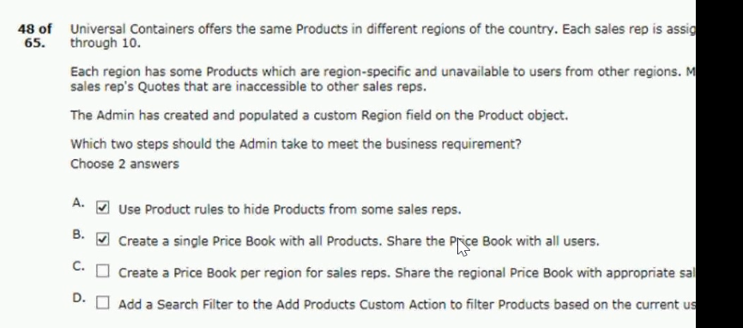

universal containers (uc) has set the cpq package settings of both subscription term unit… and an end date of..
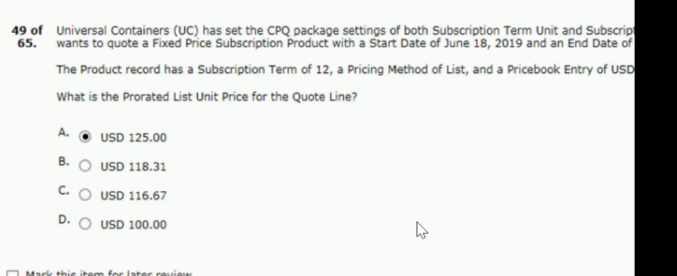
be unable to remove product a
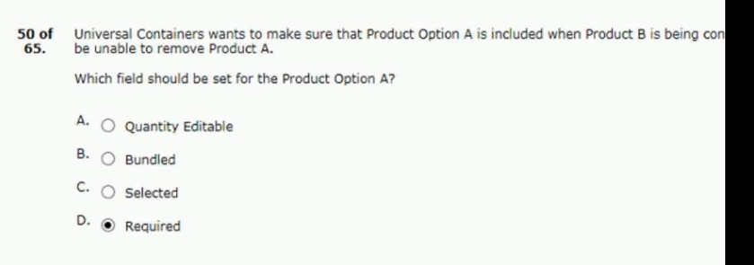

shipping container products added to the quote
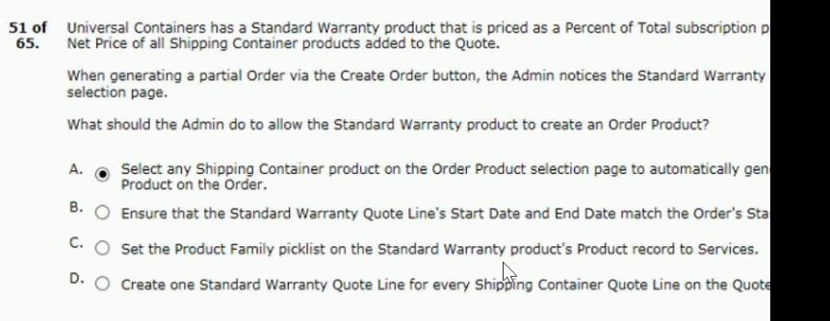
to the approval request
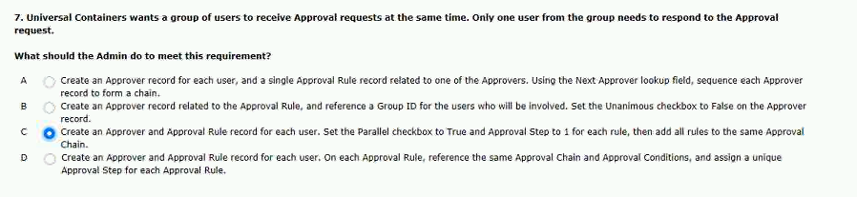

universal containers wants its users to be able to apply additional discounts in the line editor at both..
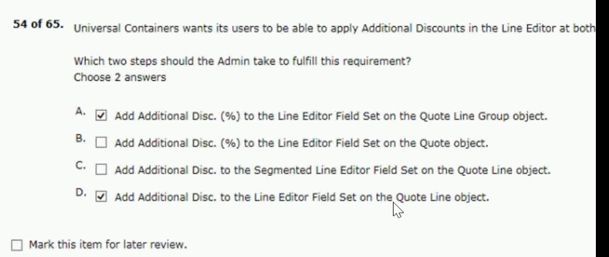
actions on quote lines in the quote line editor
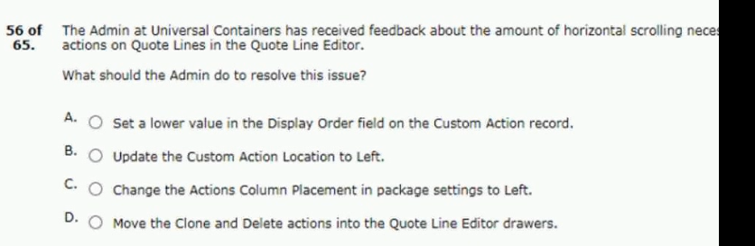
Ans C
universal containers has multiples sales teams that need to select from a subset of the product catalog..
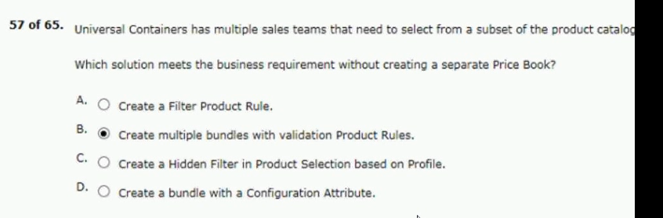

instead of an amount deducted from the list price
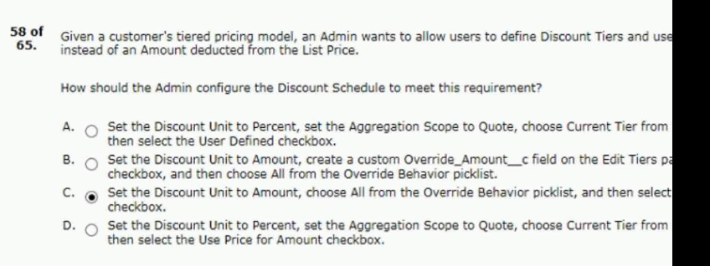
ability to change the configuration if desired
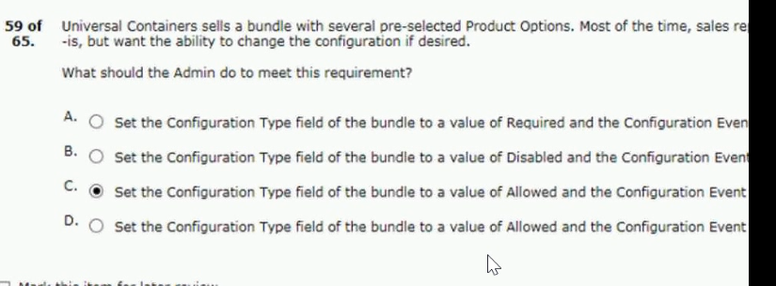
ans: C: and the configuration event field to a value of edit
admin enable renewal uplift on an account?
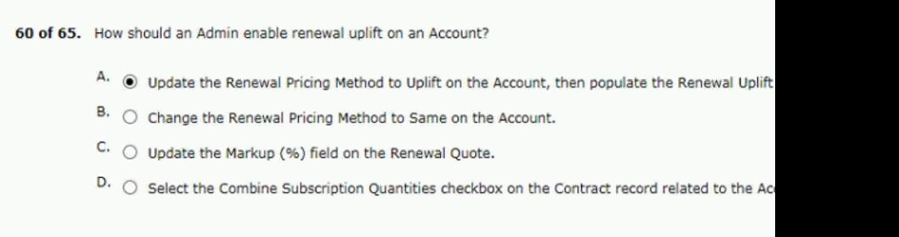

customer account with specific pricing
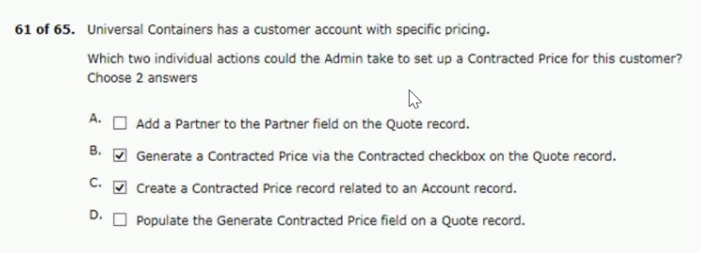
from the rendered document
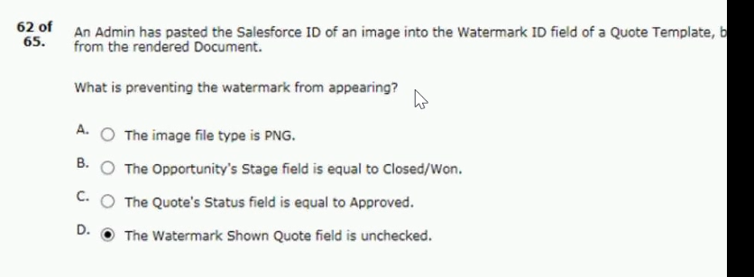
better way to manage its product catalog
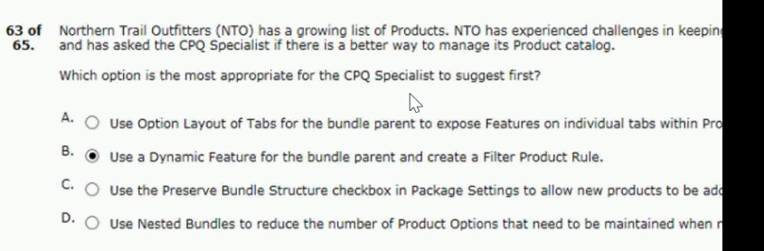

categorize the margin of each quote line
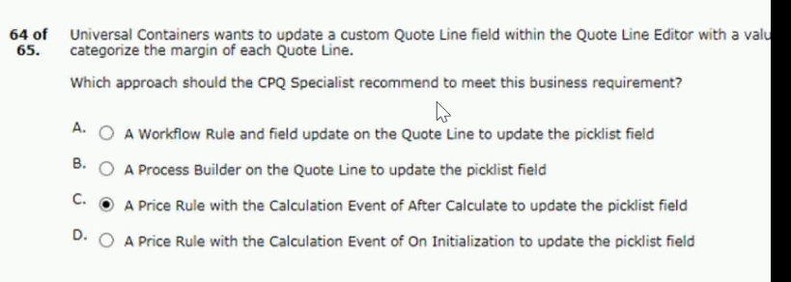
northern trail outfitters (nto) wants to reflect future renewals in its forecast pipeline as soon as the cu..
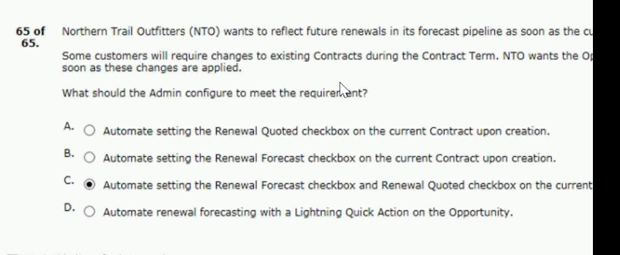
item from the product search screen.
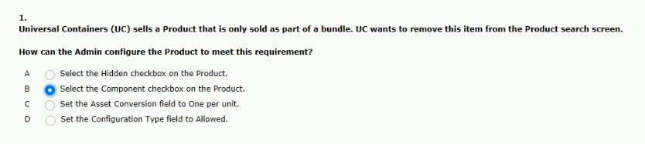

and zero error messages are displayed.

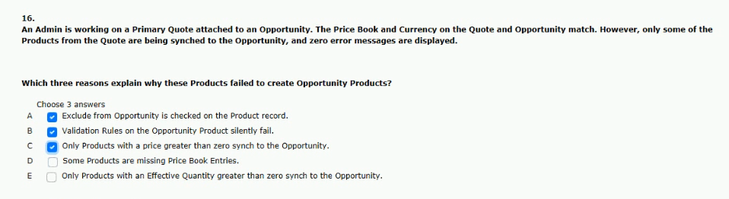
rules with an evaluation event of edit or always.
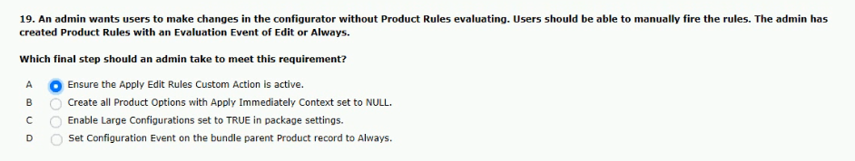
pipeline as soon as the current contract is created.
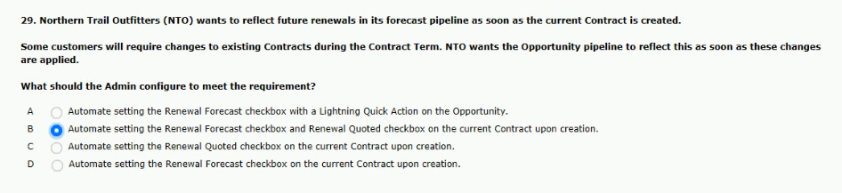
team to generate a separate order per quote line group.
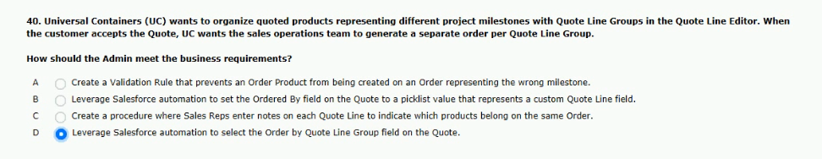

default value the moment the configuration page loads.
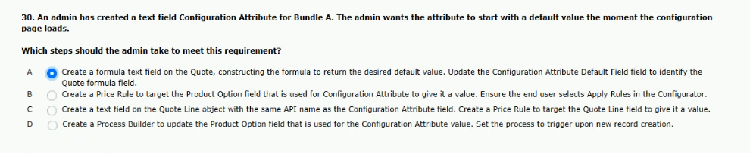
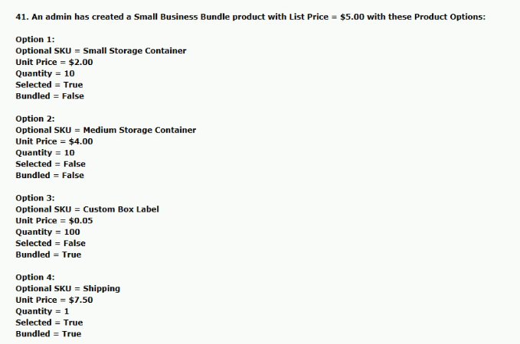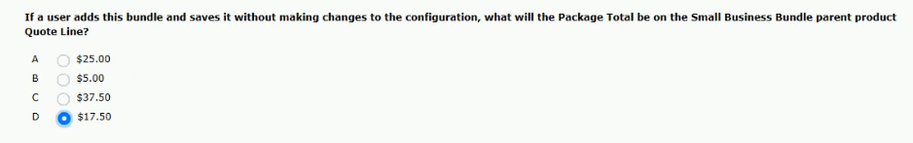

product selection screen when users search for it.
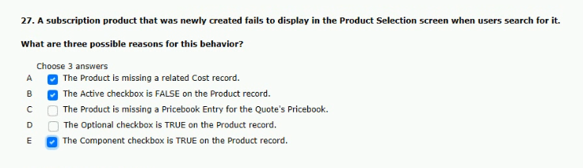
with a value the moment the configuration page loads.
on existing products when the quantity is adjusted.
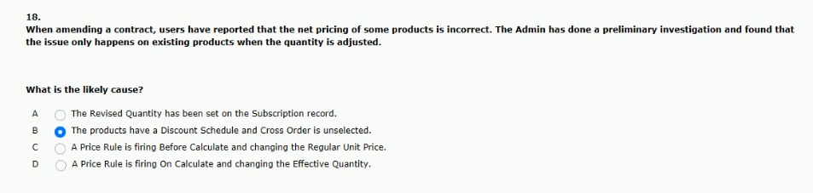
happens on existing products when the quantity is adjusted.
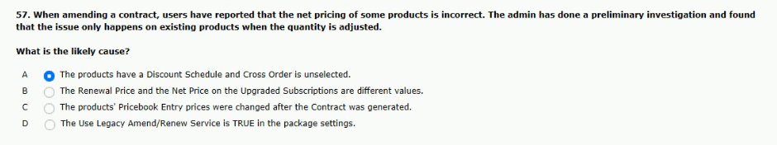

information an each contract record.
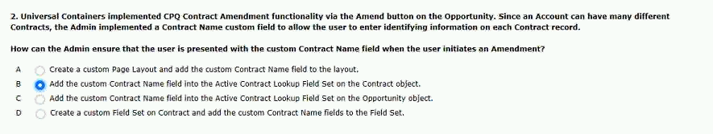
of 100 licenses for the term of the contract.
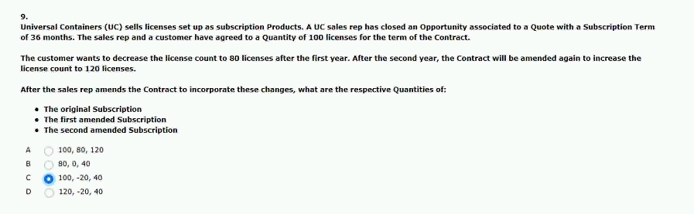
from a group in a single approval step?
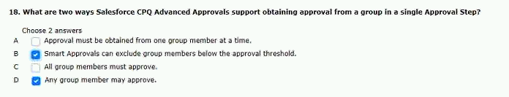
at both the quote and group level.
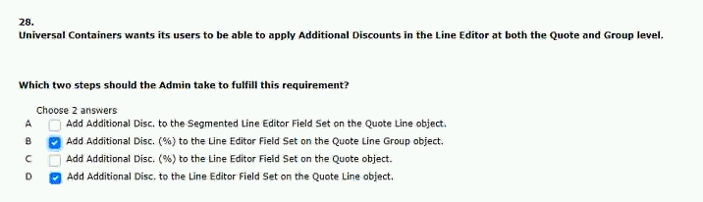

bundle parent product quote line
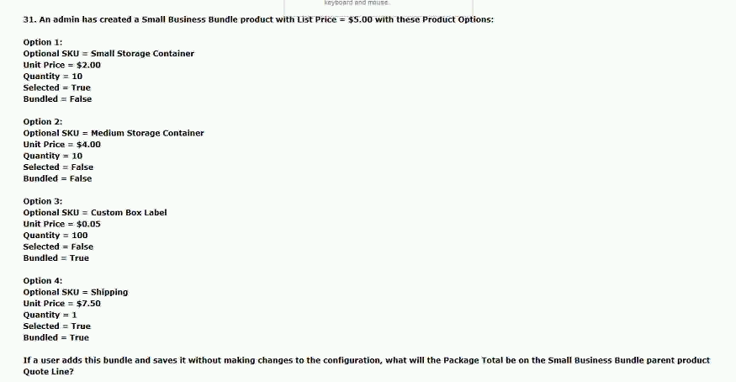
above the maintenance products.
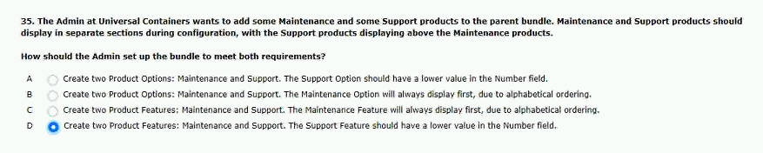
line when the sales rep clicks calculate.
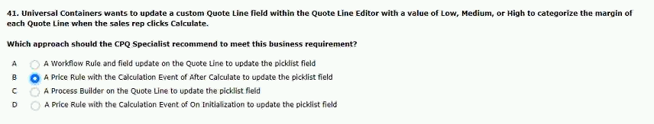

attach the brochure to each email sent.
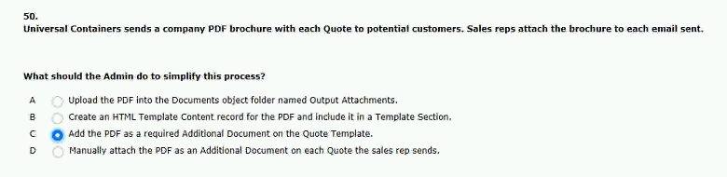
catalog on the product selection page.
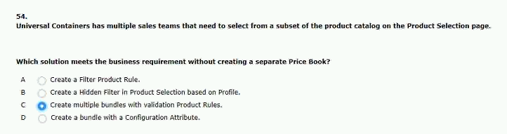
green and an operator of starts with .
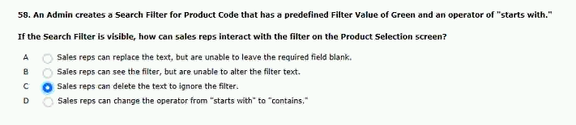
when user add products to the quote.
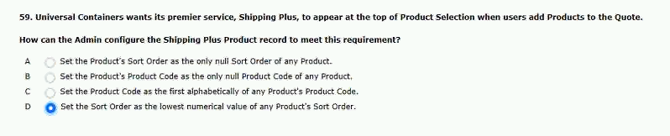

and an end date of august 21,2020.
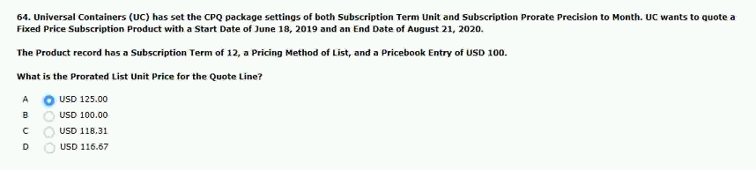
product that is priced on a yearly basis.
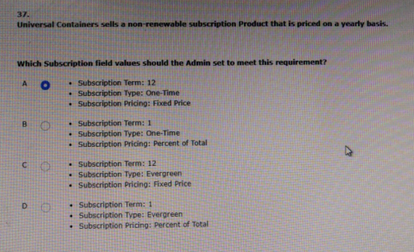
what is the correct order of data import to load products and product bundles in cpq?
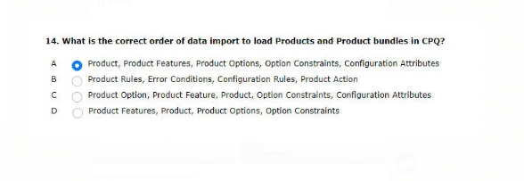

universal contains has set up an account lookup field distributor_c on the quote to identity distributors per group.distributors have a discount_level_c field populated with the base discount percentage that products provided by that distributor will receive.
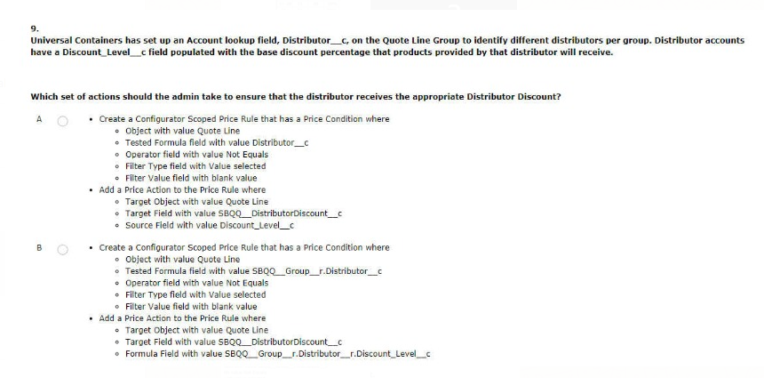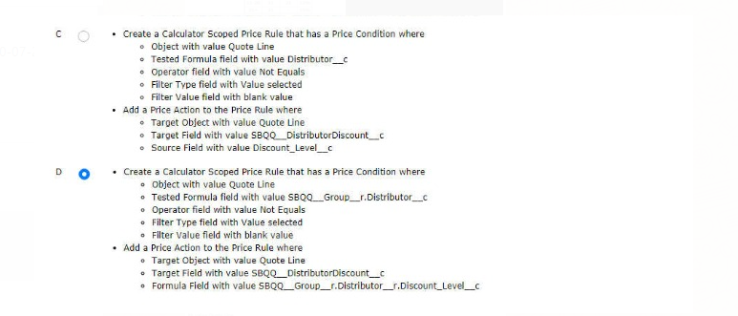

a universal containers user states that a configuration attribute value can be set up during the initial configuration but the value is absent when the user reconfigures.
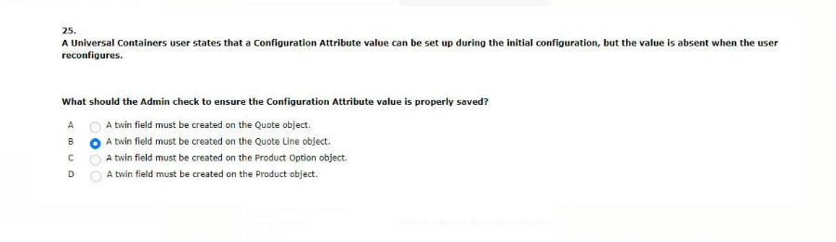
universal contains required a subset of products to be viewed based on a button on the quote line editor.
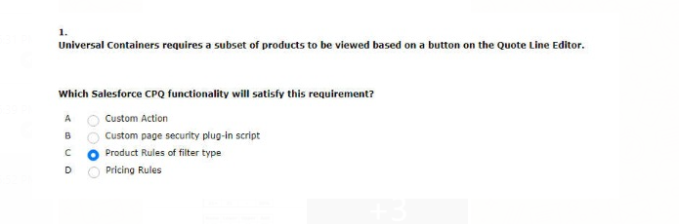
ANS:A

universal containers restricts users from selling more that 10 different products within a specific product feature at once.
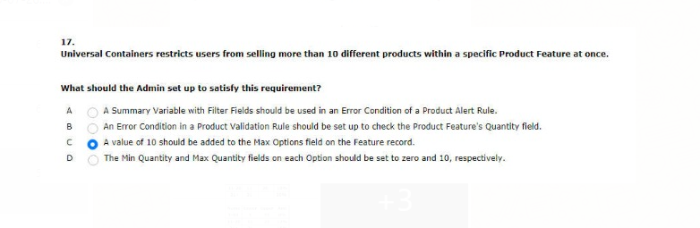

universal containers has three different range discount schedules. all three have a reference to product a through the objects shown below product a is an action in a bundle and has a list price of $100.
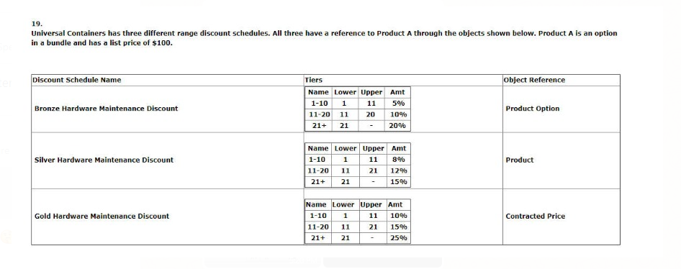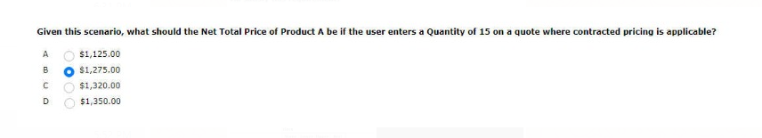

when sold a la carte a processor product should be priced at USD 200 and EUR 150.when sold as a component of a laptop bundle in USD this processor should be priced at USD 180 and EUR 135.
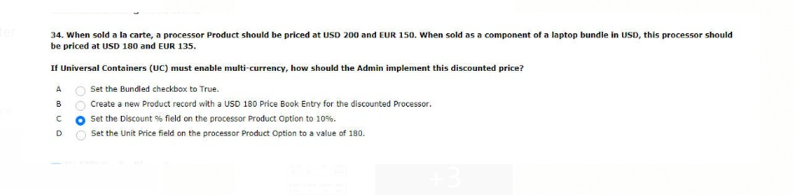

universal contains has a series of required PDF document that need to be attached to the output document when generated.these PDF files are already stored in documents.
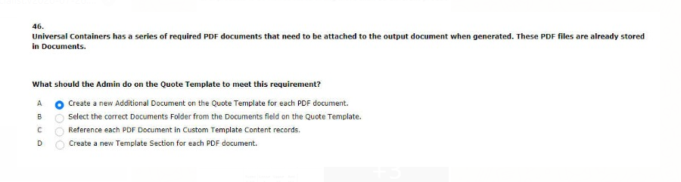

price with the following information
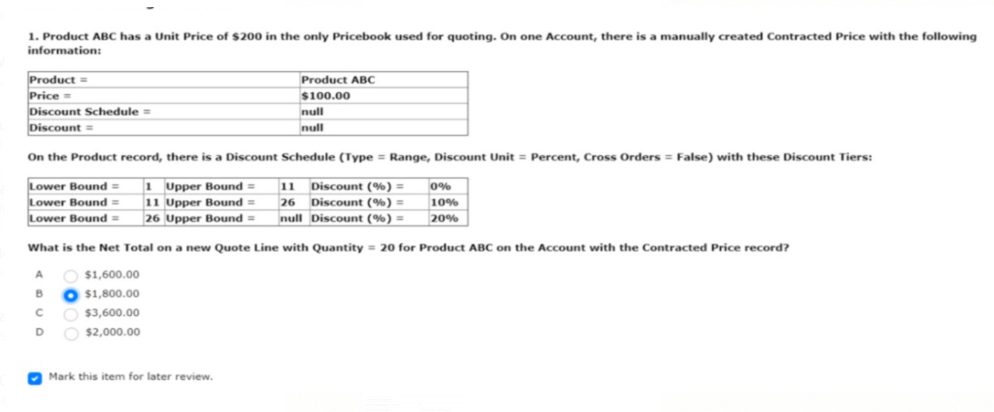
content testing within journey builder?
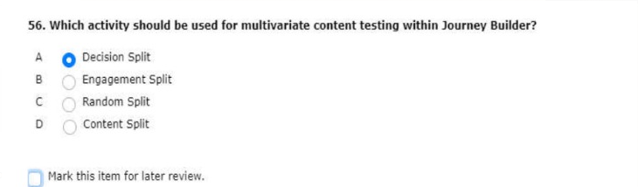
10 miles of one of their stores
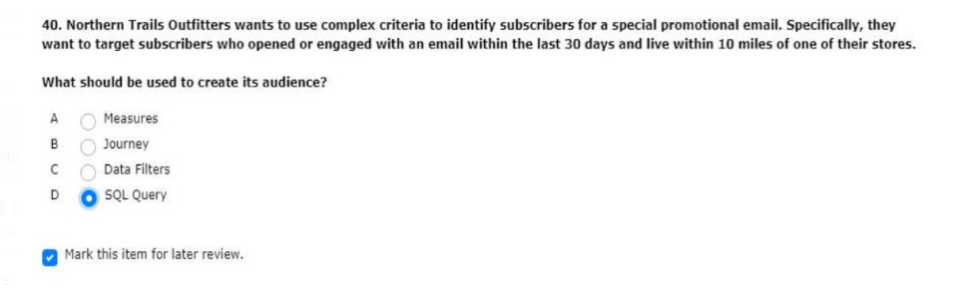

links in an email sent via email studio
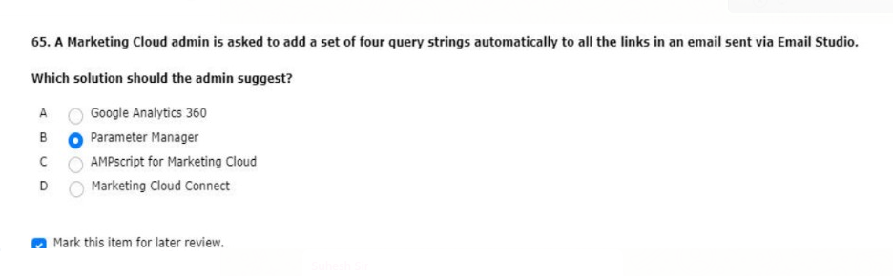

claim by calculating the support pricing

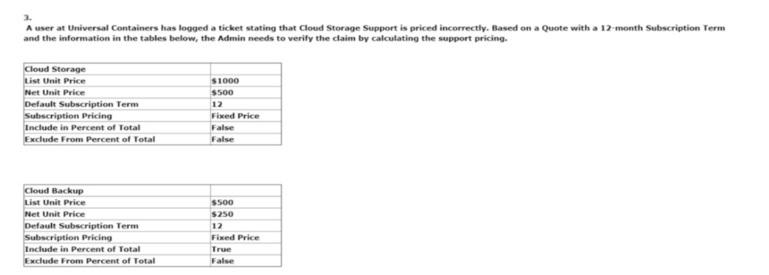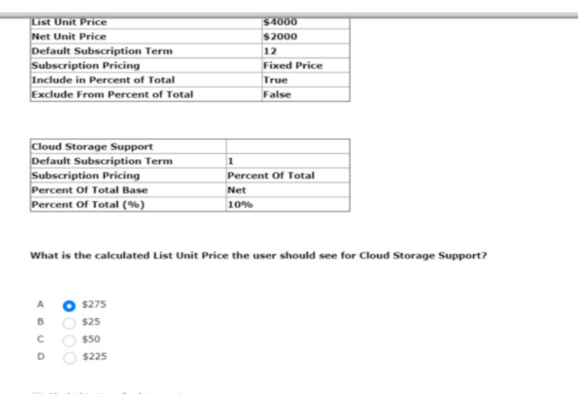

appear to be grouped incorrectly
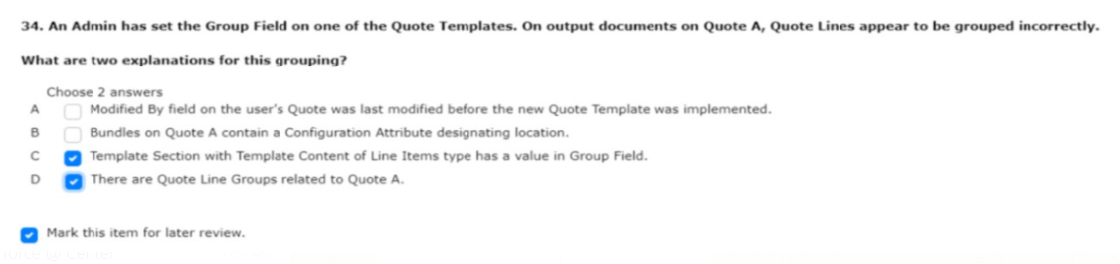
configurable with options X, Y, and Z
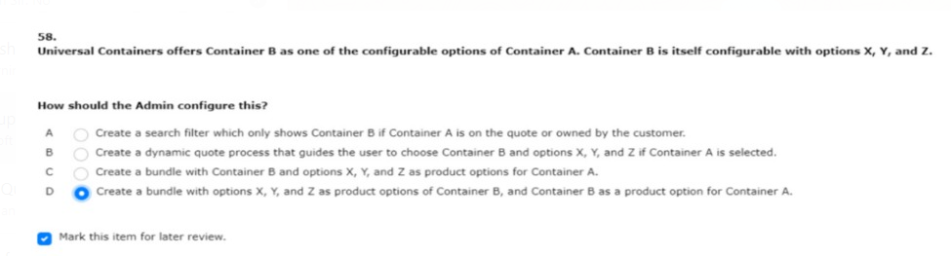
cloning bundles or pricebooks
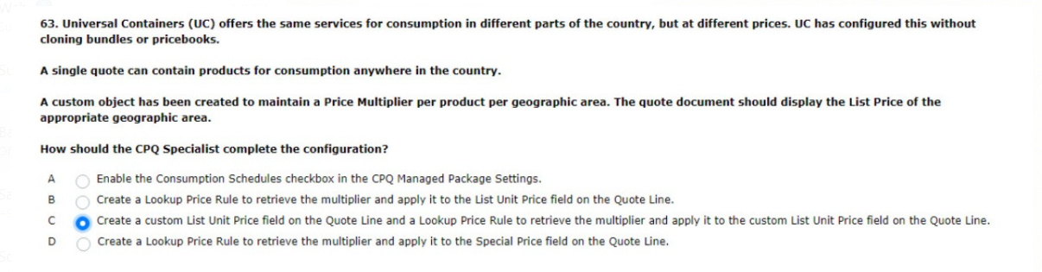

from being edited by other users
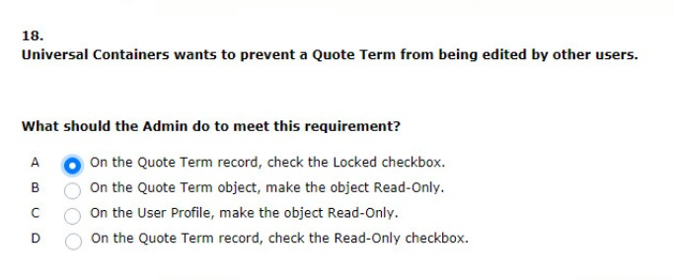
is out of sync with the latest change
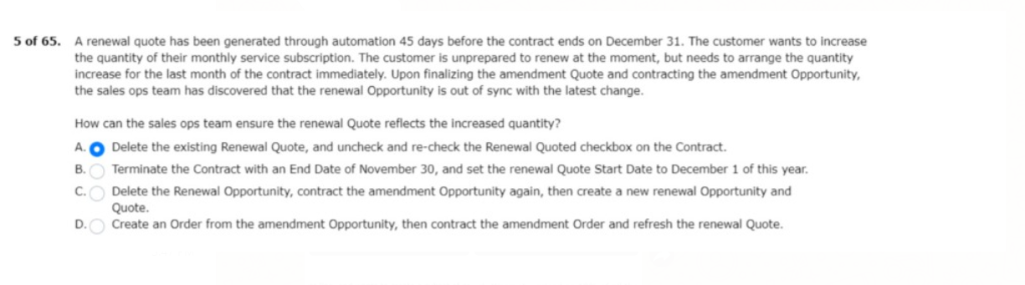
when it is sold outside of a bundle
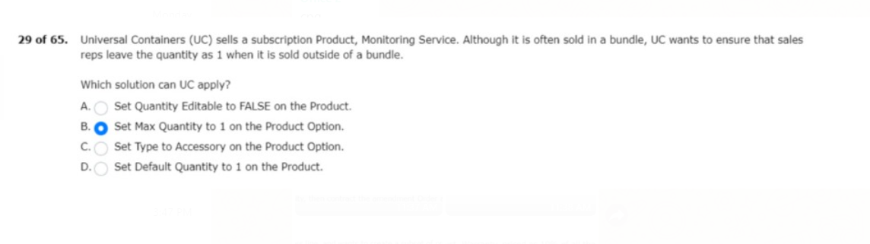

if the opportunity is flagged as eco-friendly
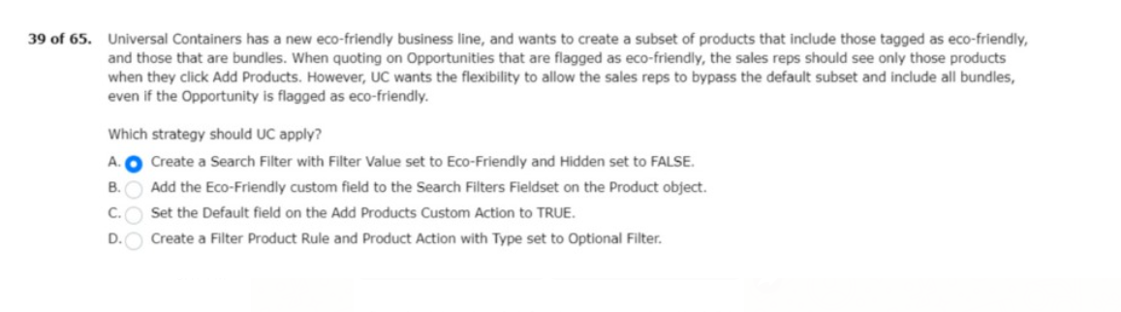
wants it to reflect the discounted prices
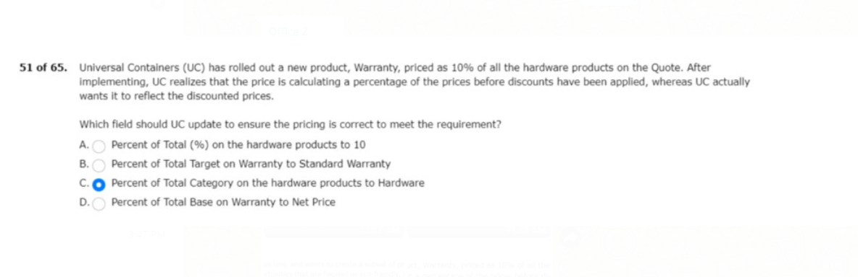
having to maintain additional product options
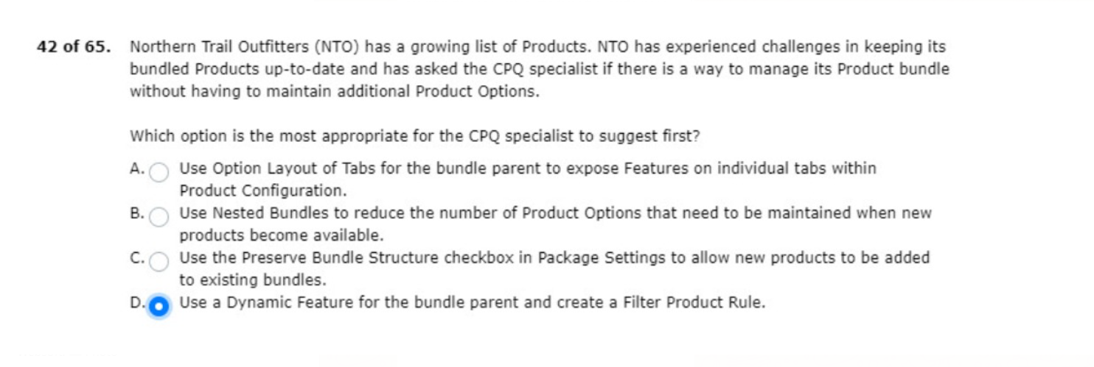

should apply only for this specific product
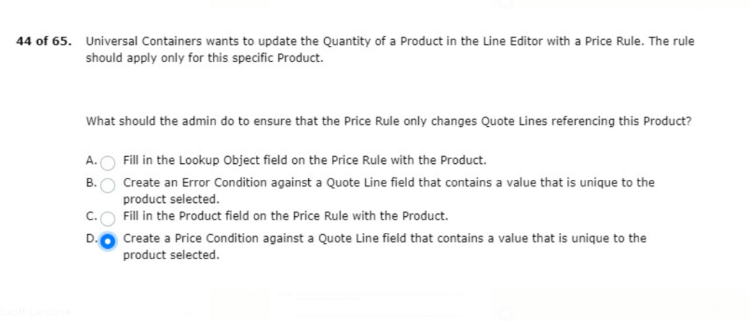
pricing can change frequently withni each segment
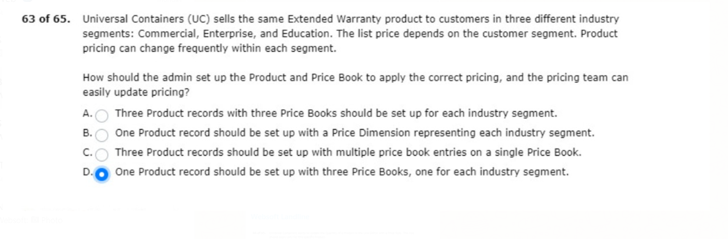
subscription product with the type of “monthly”
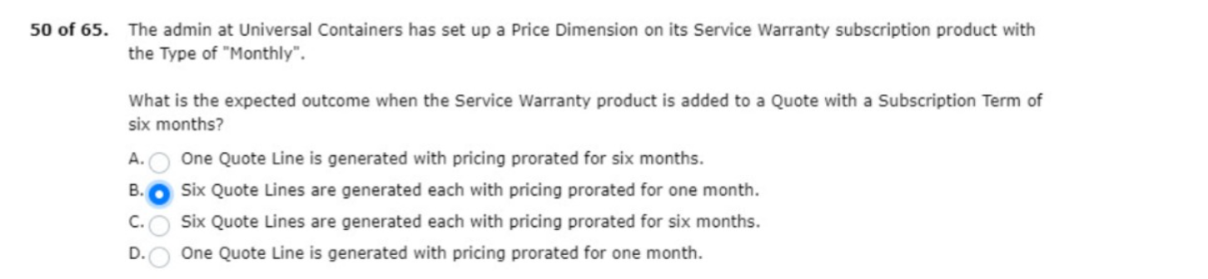

based on a custom product type quote line field
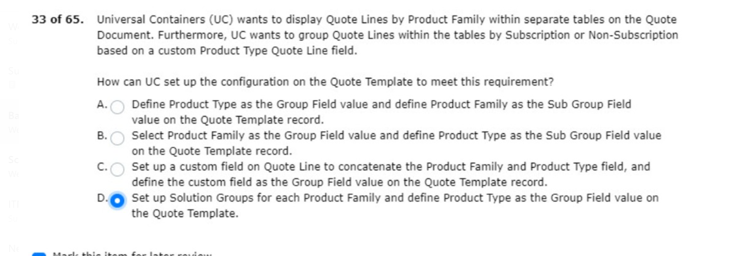
subscription service with tiered pricing
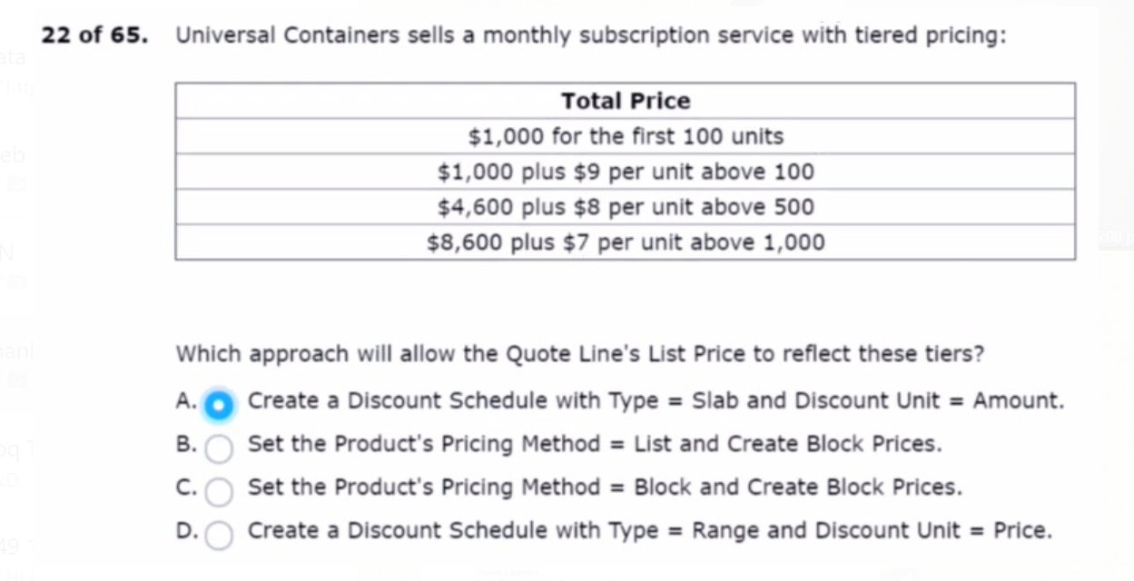
a single drag and drop action
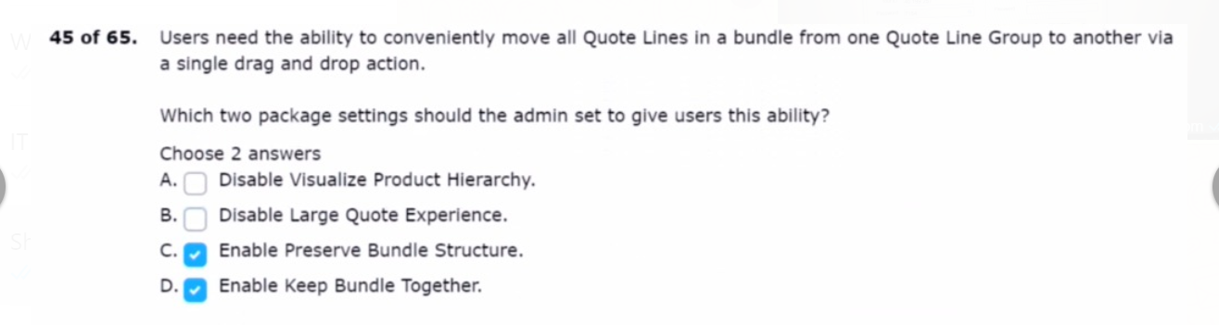
products and non-subscription products
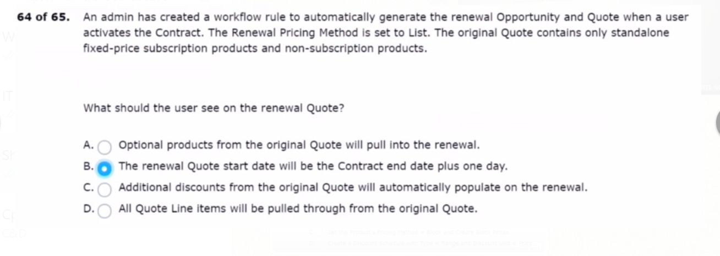
has two products
create an option constraint
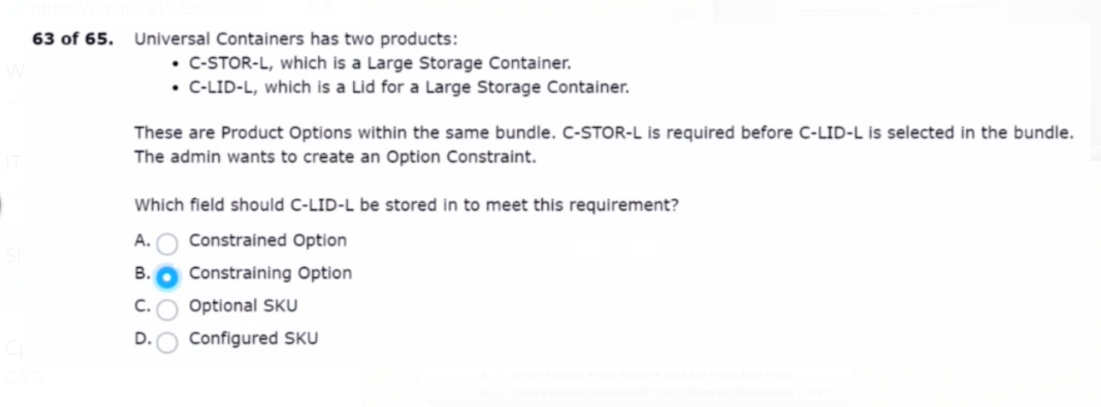
on each contract record
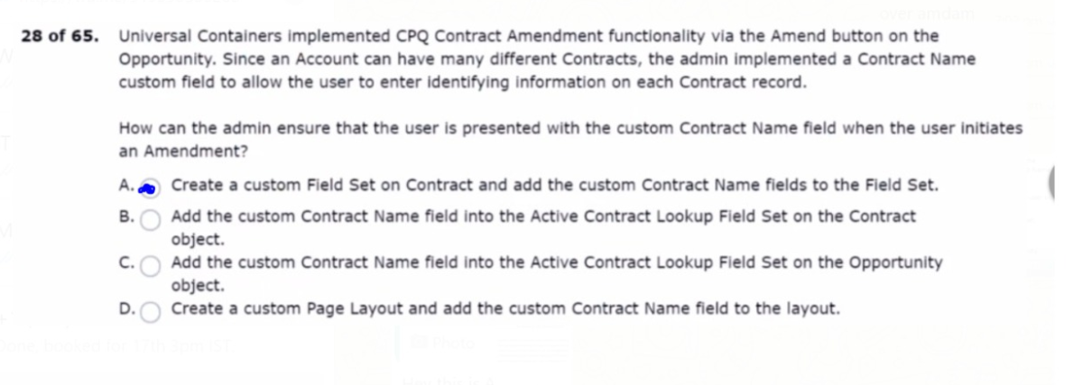
if the bill to country is canada
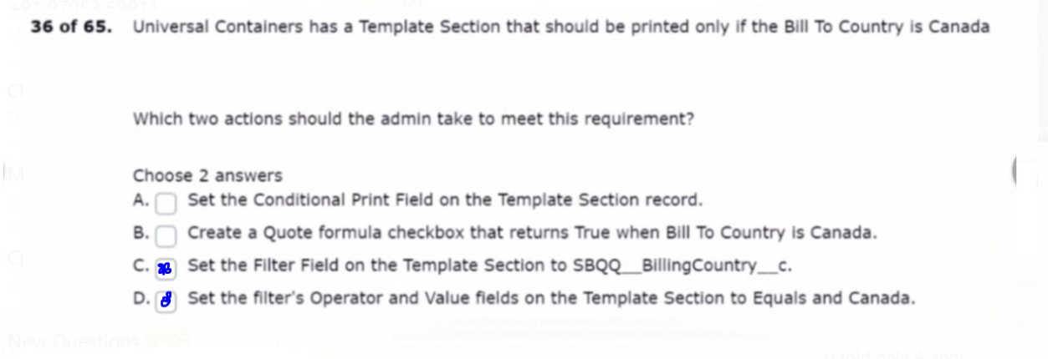
in three languages selectable by the user.
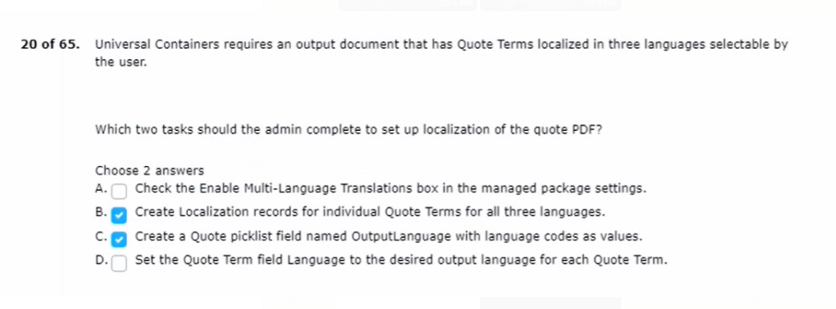
but product A has a net total of zero.
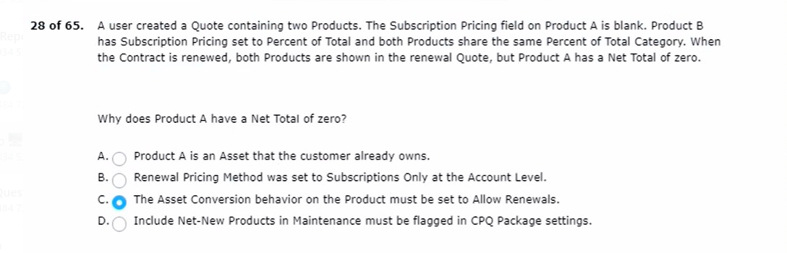

when the quote primary checkbox is false.
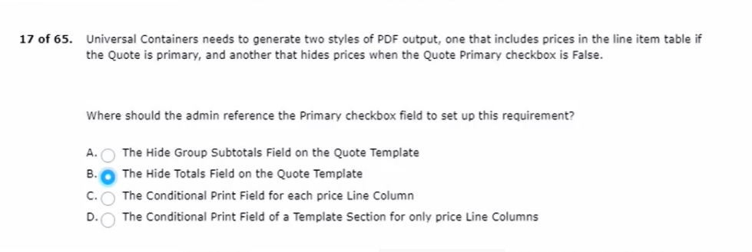
chains display on screen from left-to-right.
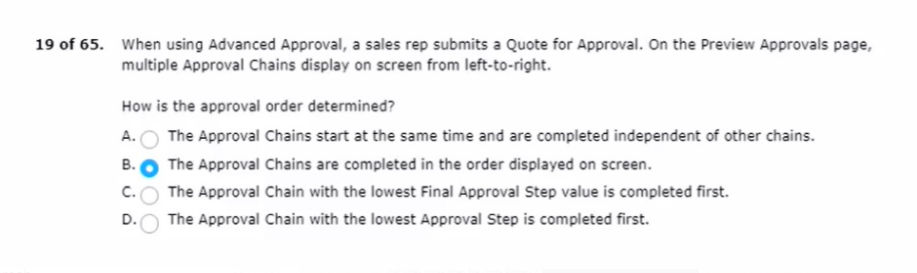
must be hidden on the generated proposal document
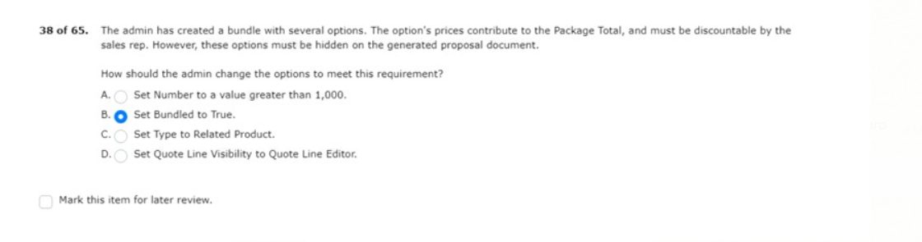

of how many quote lines are present

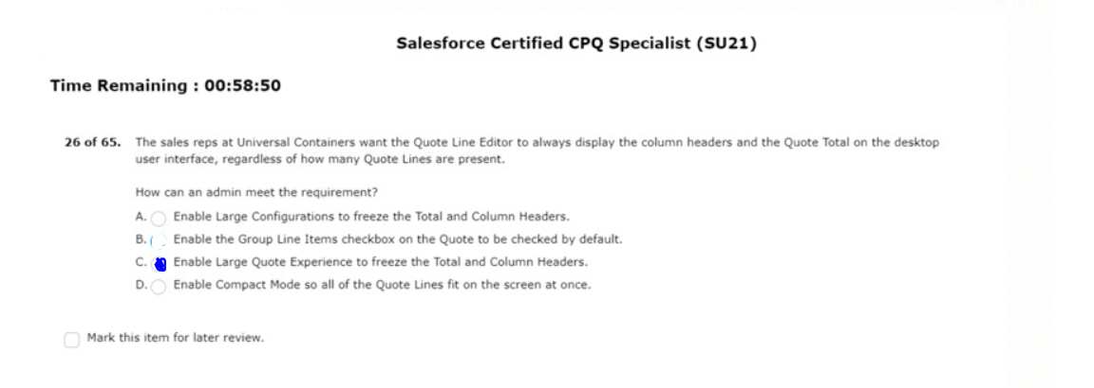
query criteria for a single quote line
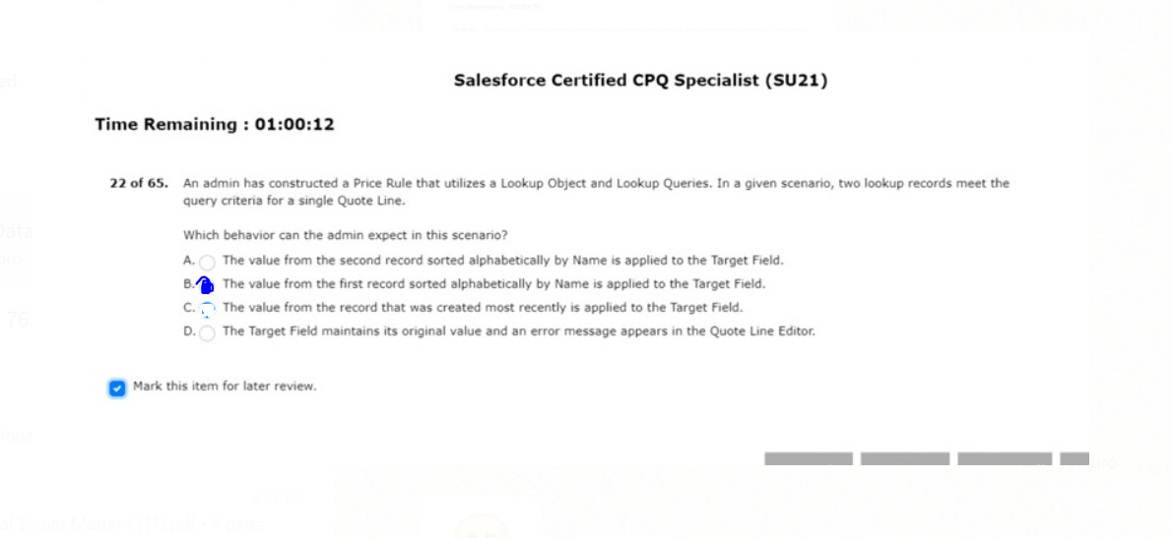

calculate buttons in the quote line editor?
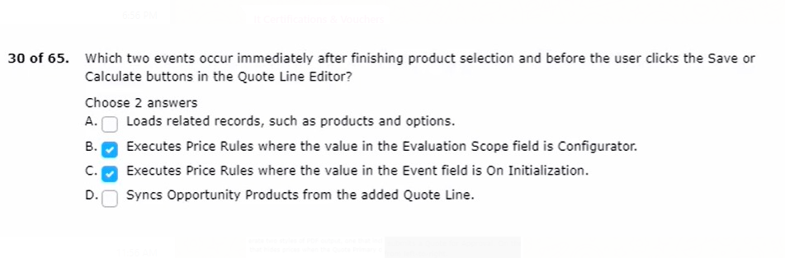
based discount and a $20 term-based discount.
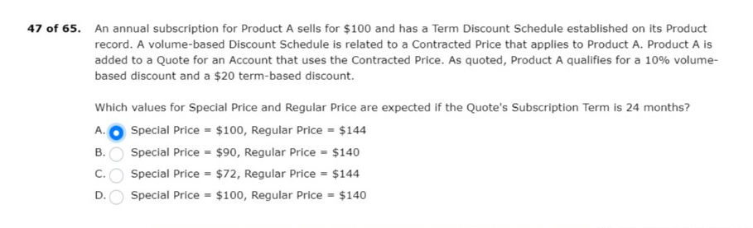

is unchecked and is related to a custom action.
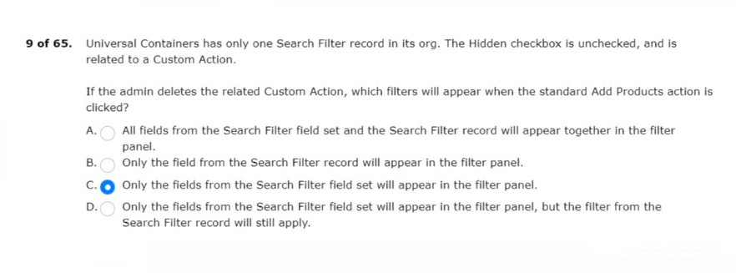
ANS:C OR D

into the line editor field set on the quote line object.

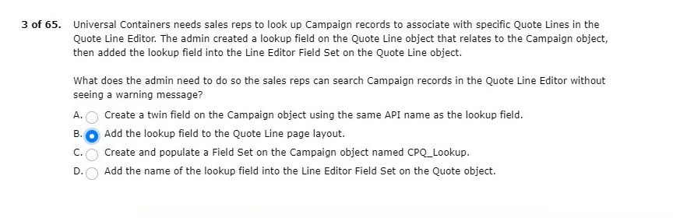
when the user selects a specific configuration attribute.
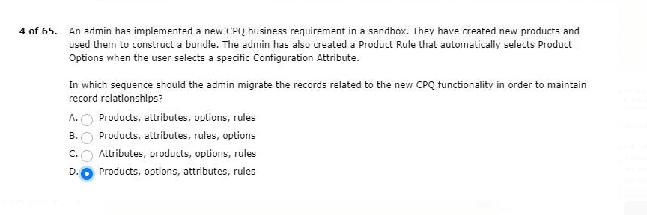

universal containers has five products.
are added to a quote with a quantity of 1?
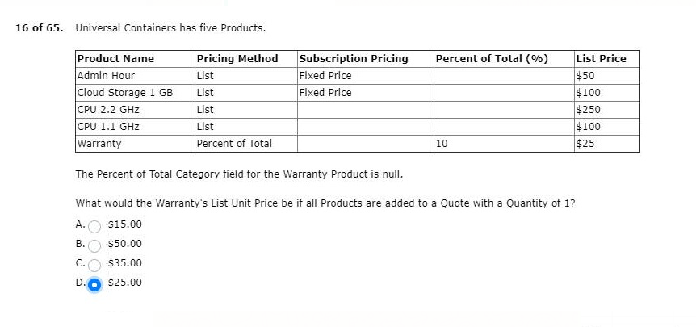
with an end date that differs from the quote’s end date?
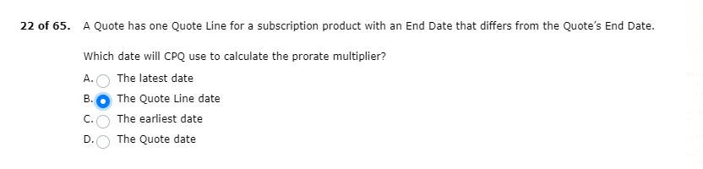

net total price and carry a team of 12 months.
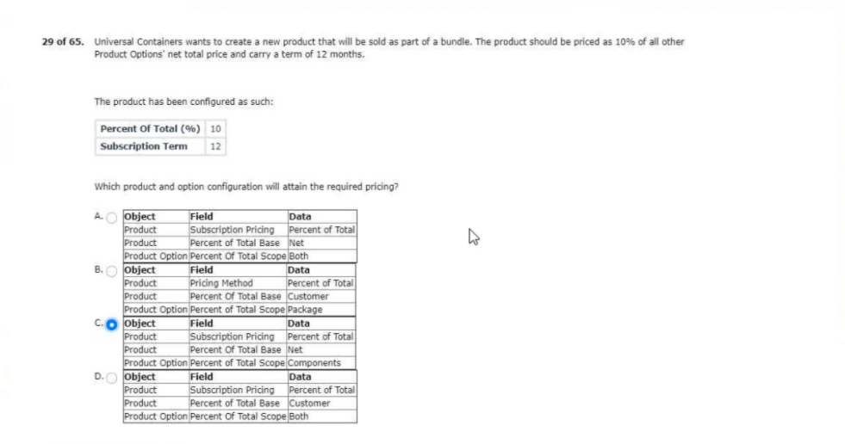
prevents CPQ from generating records for which object?
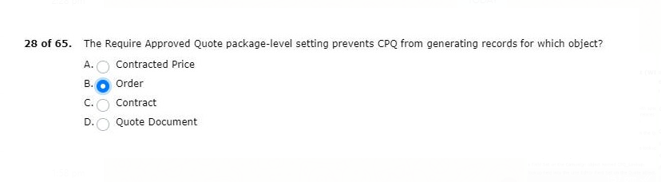

displayed when using the filter action in product selection.
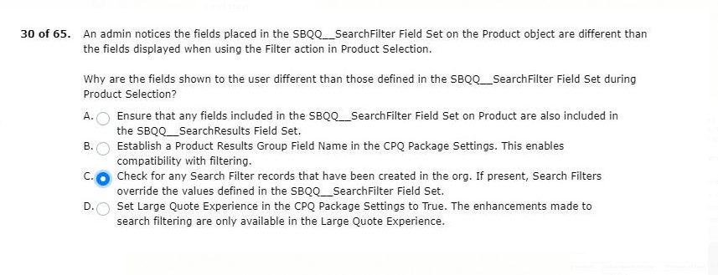

bundle product with list price=$5.00 with these product options:
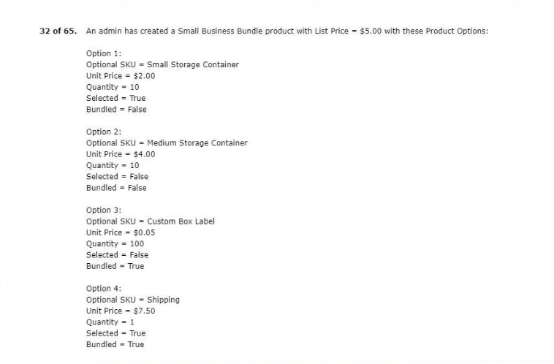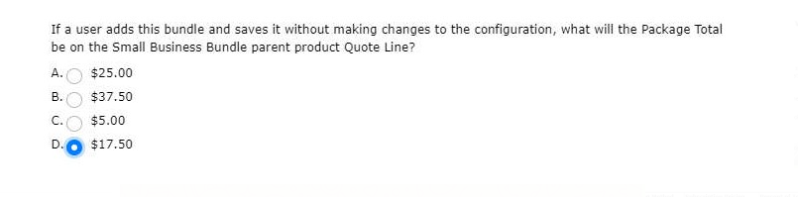

add a conference pass product to all new quotes?
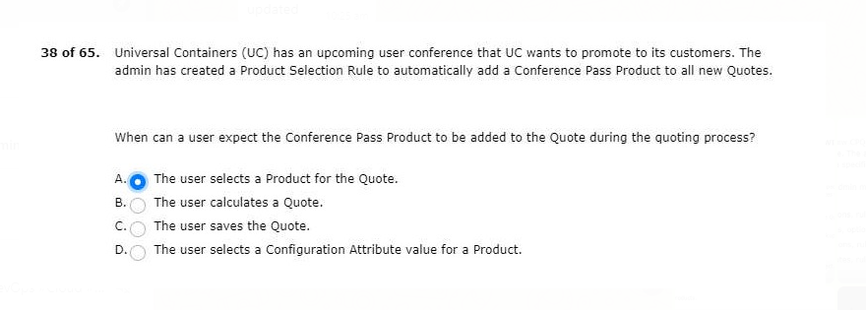
save the new value to the quote line editor.
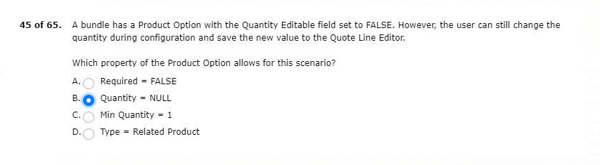
based on a button on the quote line editor.
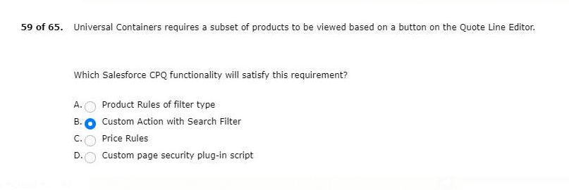

and define options quantity via bundle configuration.
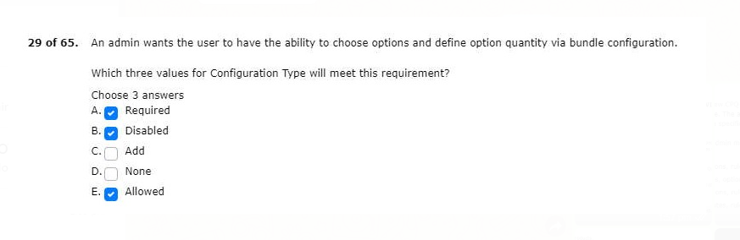
1.Set to change the columns that are visible during configuration?
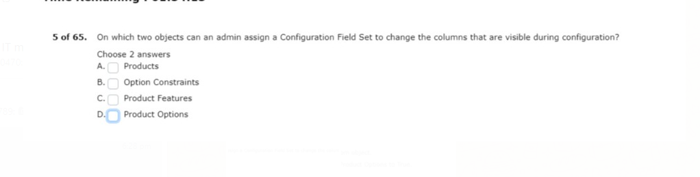
ANS:CD
2.The volume selected at the bundle level must match the volume of every product option.
volume that will apply to all product options?
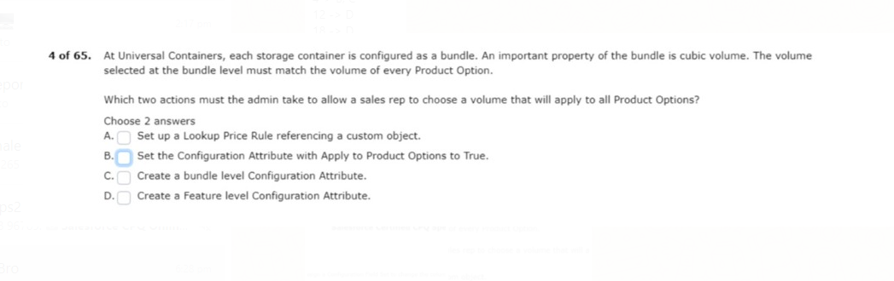
ANS:BC

3.Before CO-terminating a new quote with an existing contract?
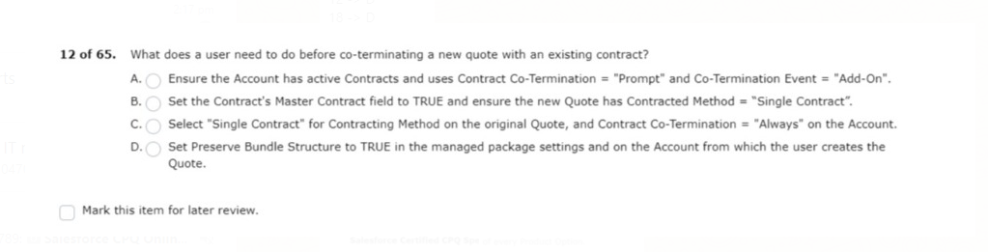
ANS: D
4.Unsegmented when it is first added to a quote with the option to segment when needed .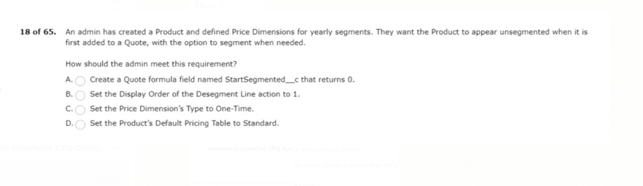
ANS: D
5.That creates a renewal opportunity from the contract.
multiple records related to product A?
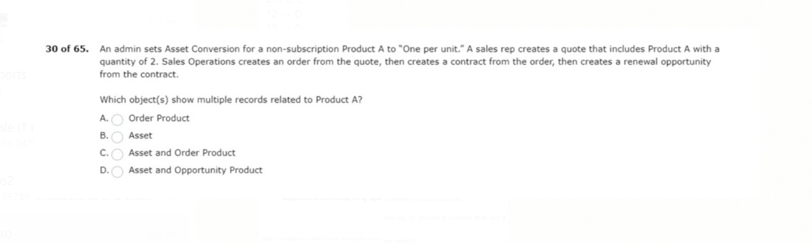
ANS:B

6.Universal containers sells a monthly subscription service with tiered pricing :
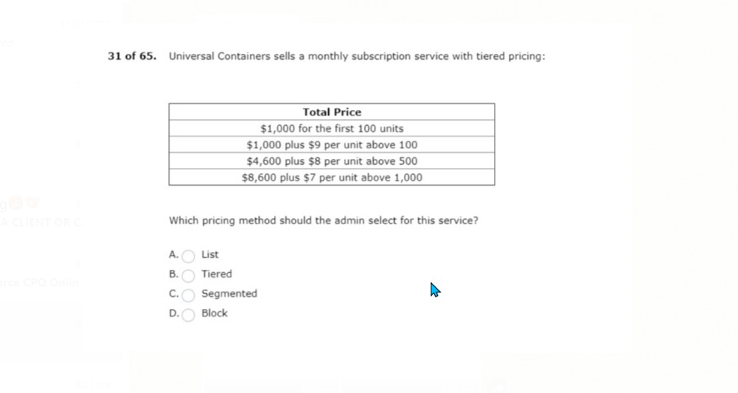
ANS:D
7.Product options for other quote lines within the quote line editor?
based on the quarte line’s position within the bundle ?
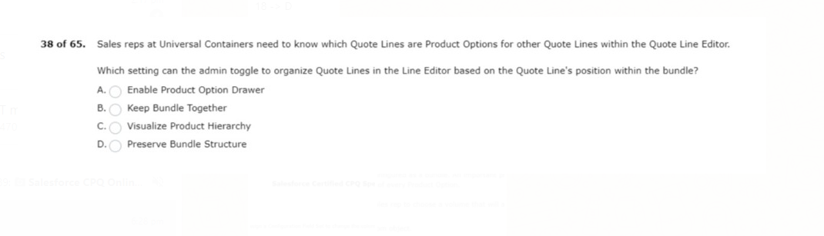
ANS: B

8.Contains fewer values then the field from the product option.
and then tries to save the bundle ?
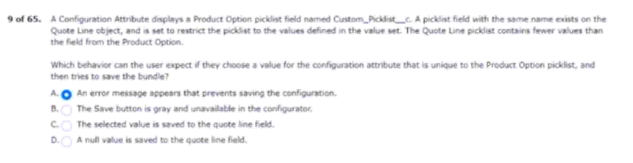

9.Value for the condition met field of a price rule ?
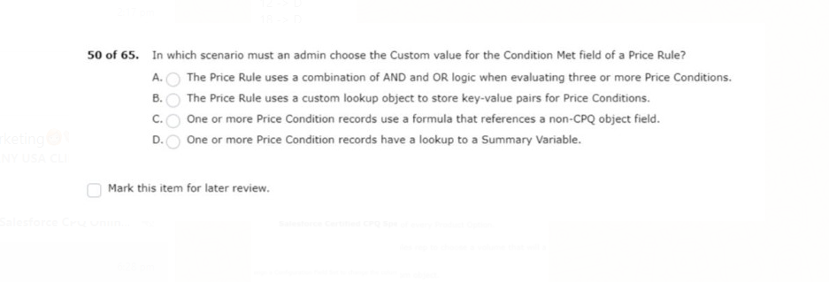
ANS: A

10.And Eur and has multi-currency enabled.
American customers and one for Asia pacific customers.

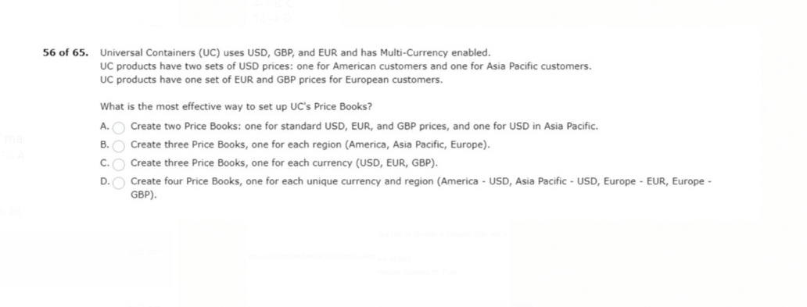
ANS: D
11.Approval requests will be routed prior to submitting a quote for approval.
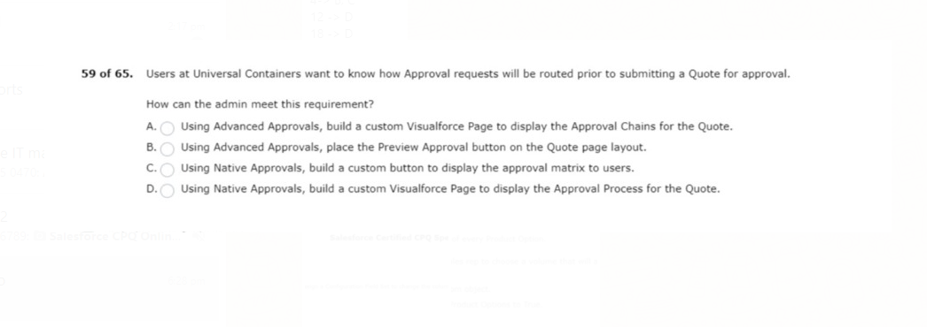
ANS: B

12.Before discounts have been applied whereas uc actually wants it to reflect the discounted prices.
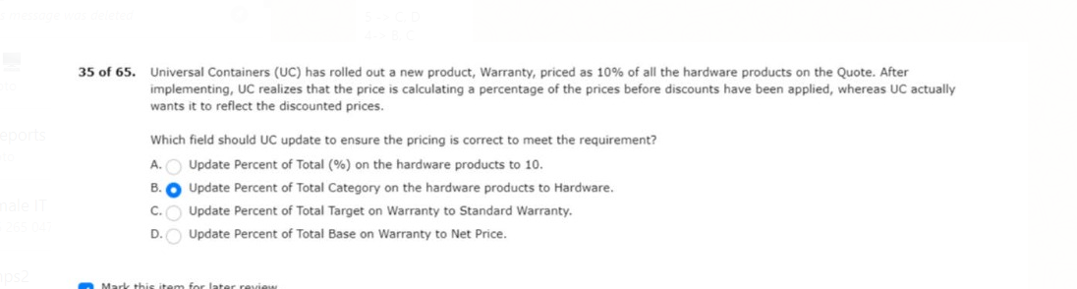
ANS: D

1.The other filter is based on product family and hidden = true .
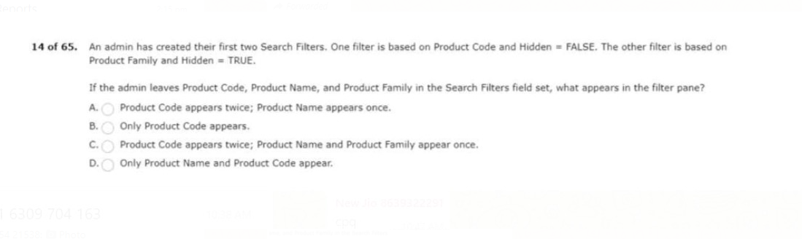
ANS: D
2.Uc wants to remove this item from the product search screen.
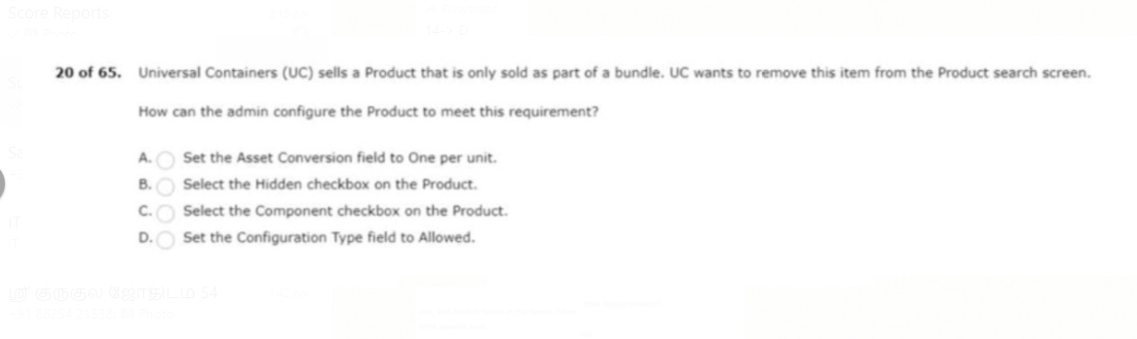
ANS: C

3. change the quantity on an order product?
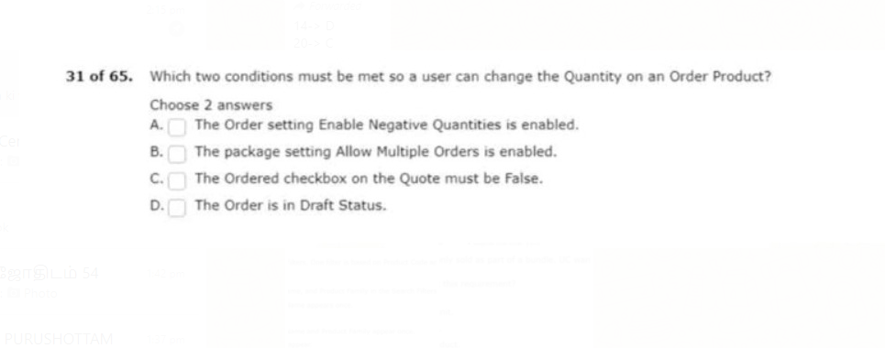ANS: BD
4. user should be unable to select product B unless the user has also selected product A.
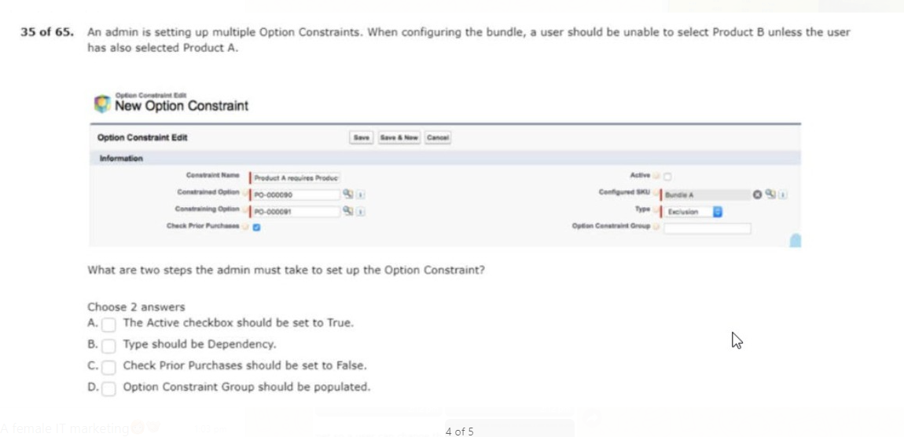
ANS: AB

5. calculated price for the standard pricing fields?
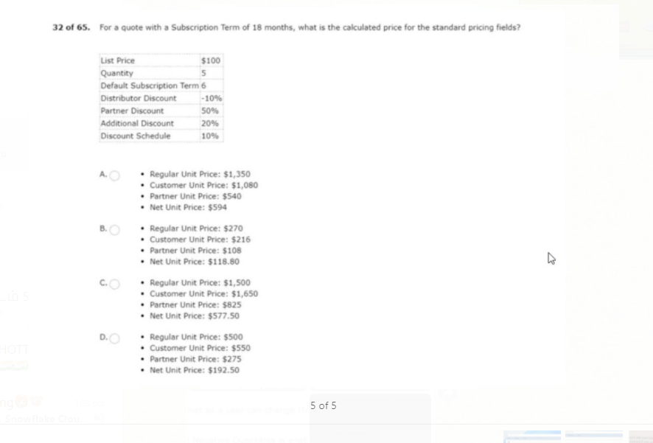
ANS: B
6. client has already purchased this team. product A is an asset product.
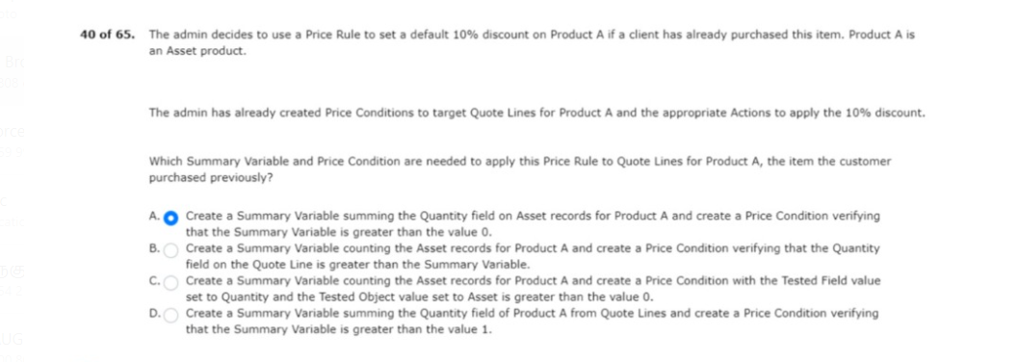
ANS: C

7. specific distributors and those distributors business units (child accounts).
on the product family of storage.
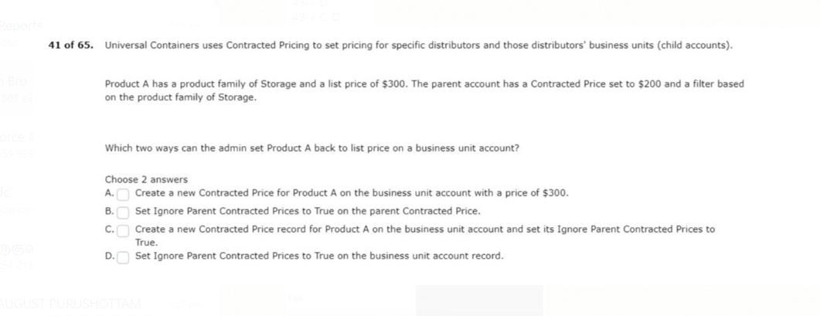
ANS: AD
8. search filter for products flagged as subscription products.
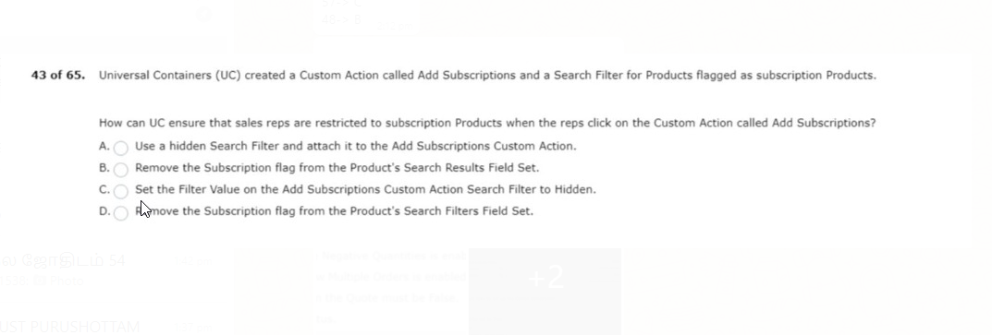
ANS: A

9.model requires that approval requests are assigned to the user’s direct manager .
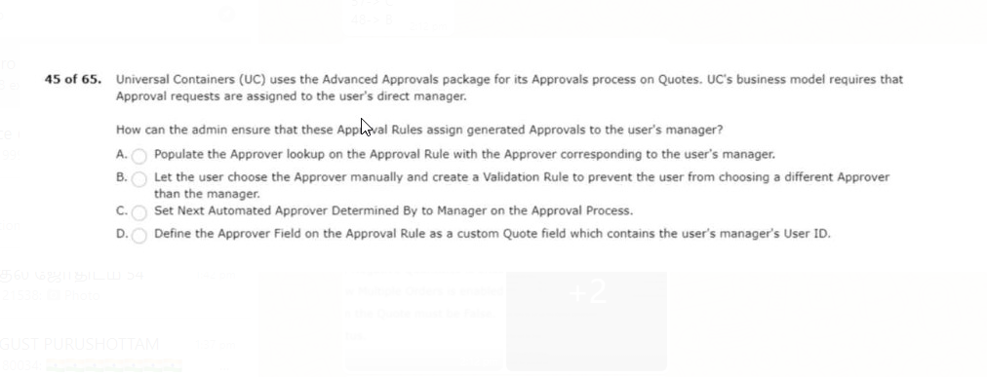
ANS: D
10. information prior to submitting them for approval.
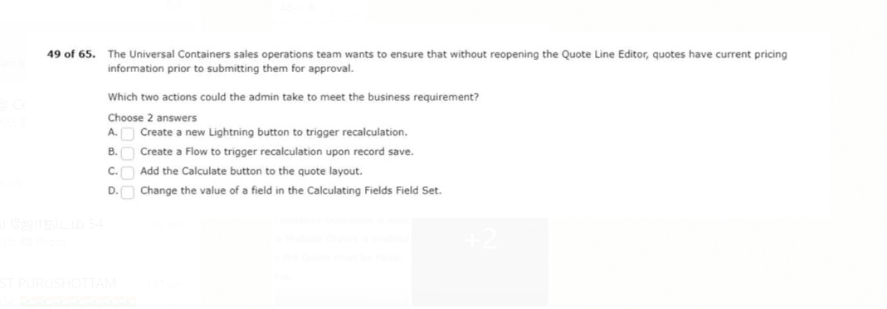
ANS: CD

11. sold by uc contains a combination of assets and subscriptions.
bundle is excluded in the amendment quote.
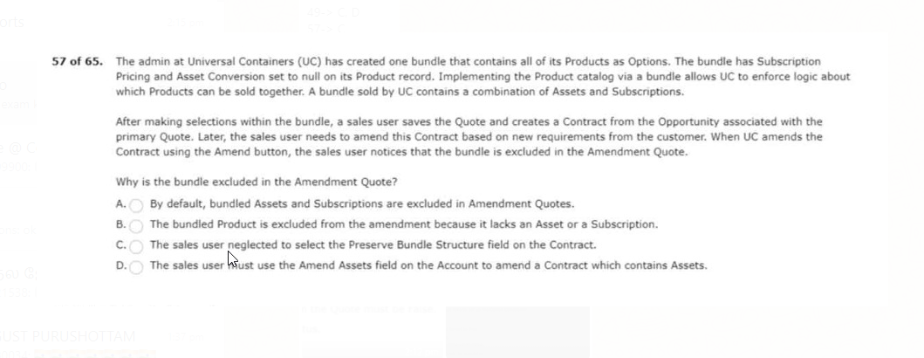
ANS: C
12. and EUR and has multi-currency enabled.
one for asia pacific customers.
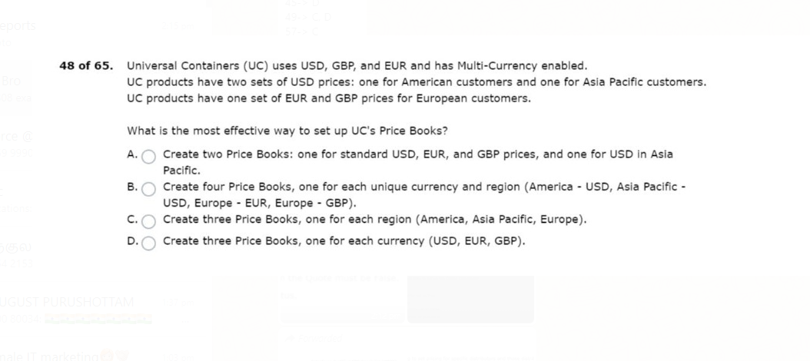
ANS: B

