the contact retail_opt_in_c picklist field to yes
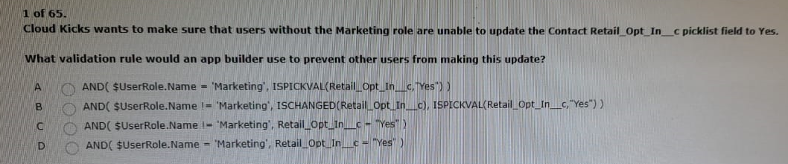
Ans: B
admin owns all of the accounts in the uc org
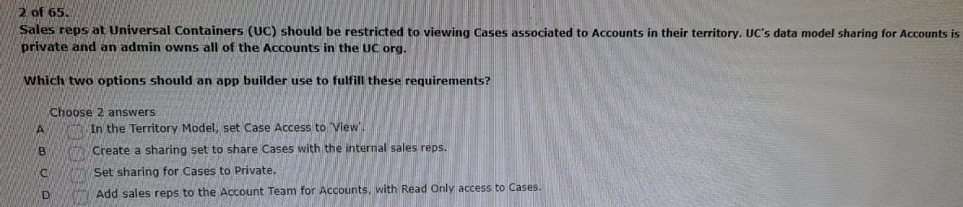
Ans: AD
create a custom object and 10 fields
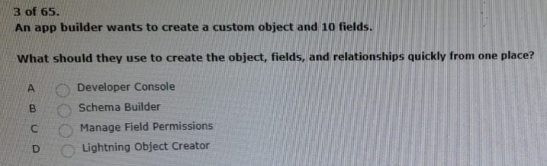
Ans: B
customer contacts using the contacts tab
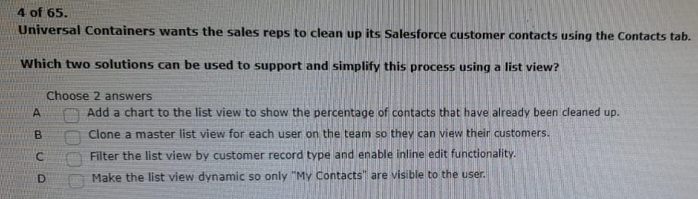
Ans: AC
page layout to improve efficiency and collaboration
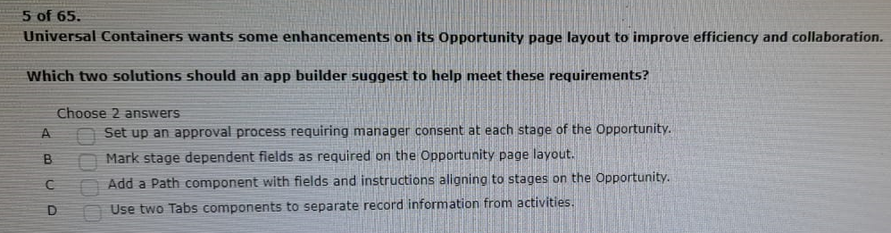
Ans: BC
choosing a template for a new lightning record page?
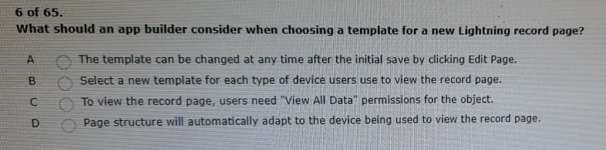
Ans: A
when making it new report for records they own
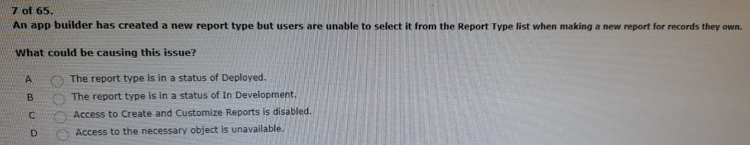
Ans: B
that is used from date to date/time
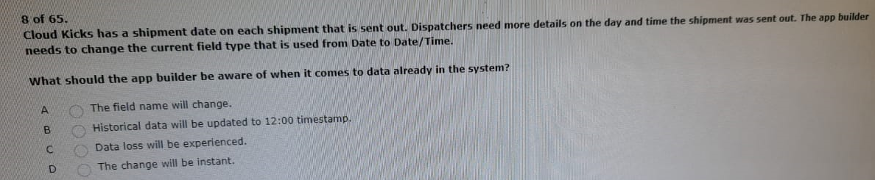
Ans: C

users not seeing the new item on the layout
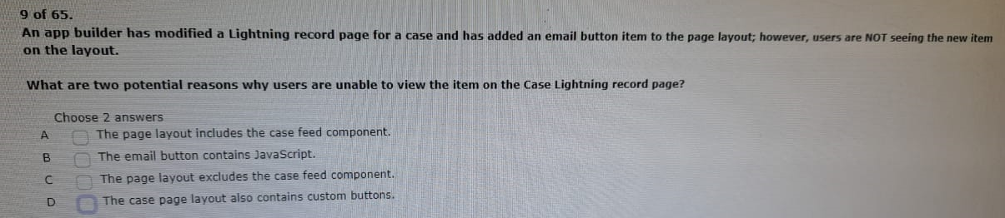
Ans: AB
how ever it will migrate this org to lightning experience
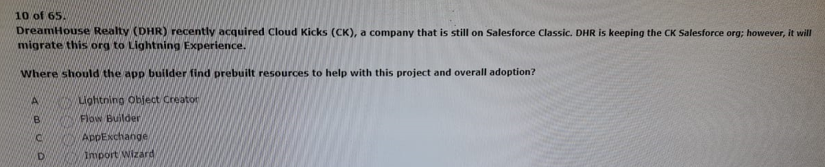
Ans: A
and should see different values for the same fields
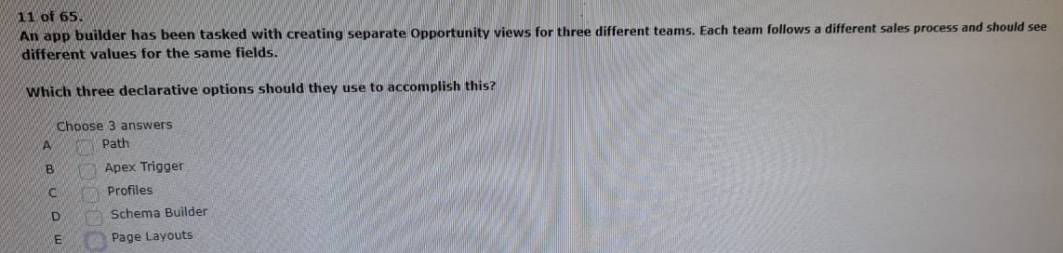
Ans: ACE
c records that have their picklist status set to active
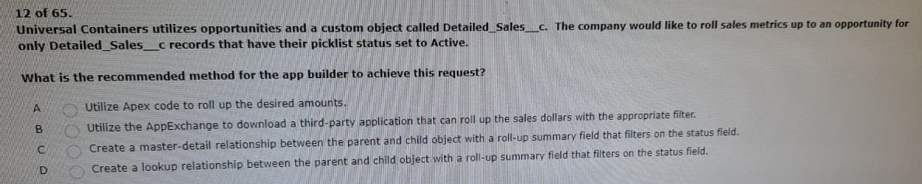

Ans: C

a project that will clean up this ord during lightning migration
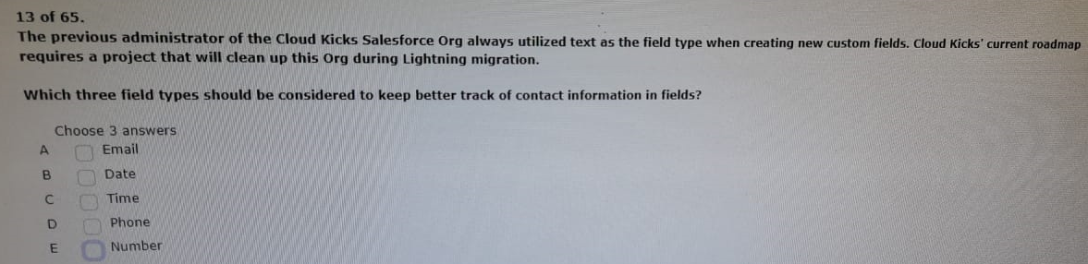
Ans: ABD
the application lifecycle management process to its release management strategy
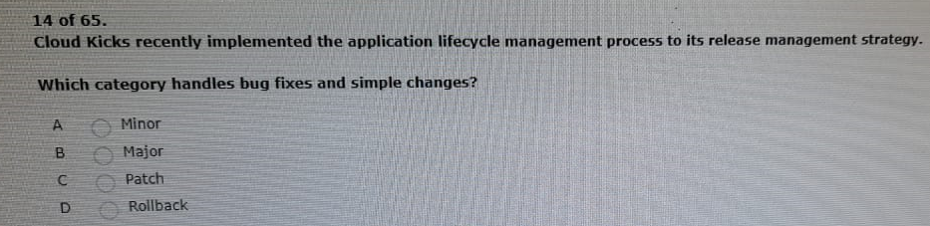

Ans: A
every time there is an owner change on the case
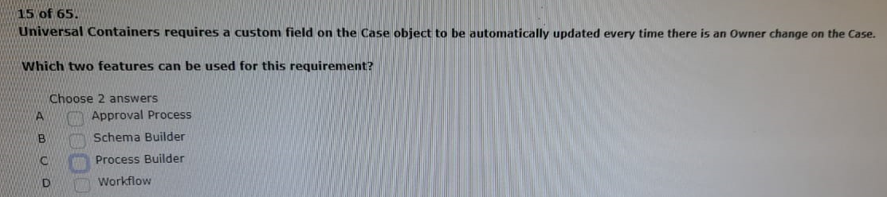
Ans: CD
custom lightning components in their org
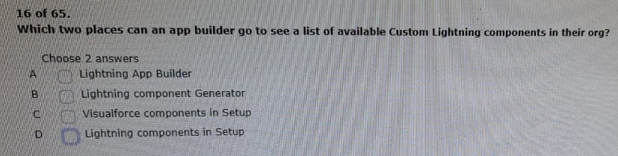
Ans: BD
for this field on each object
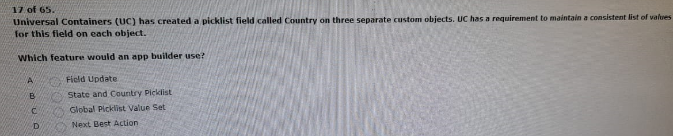
Ans: C
about ways to create an enhanced user experience
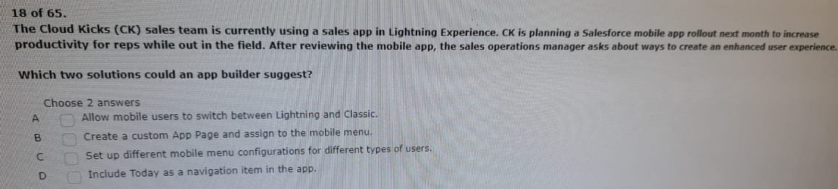
Ans: CD
home is published on the web
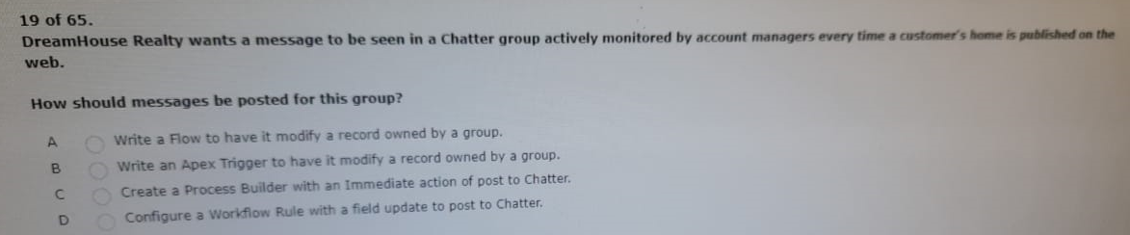
Ans: C
num_open_cases_c and num_closed_cases_c
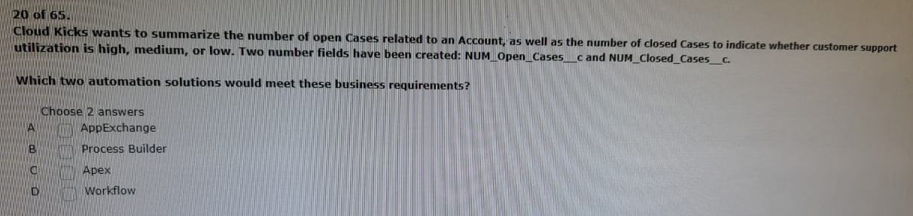
Ans: BC

open positions using a single application
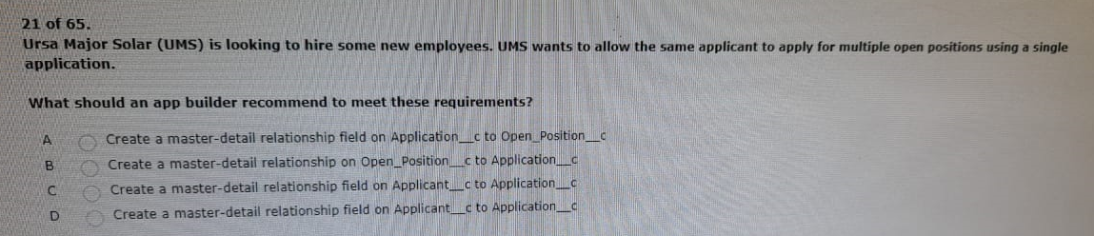
Ans: B
need to be deployed from sandbox to production
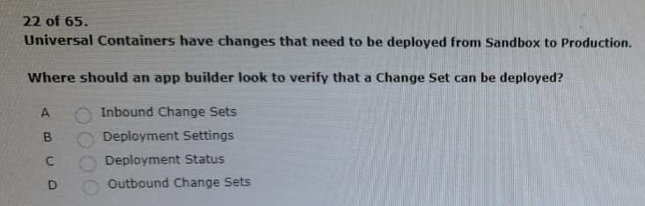
Ans: C
need to see the jupiter filed on the solar system object
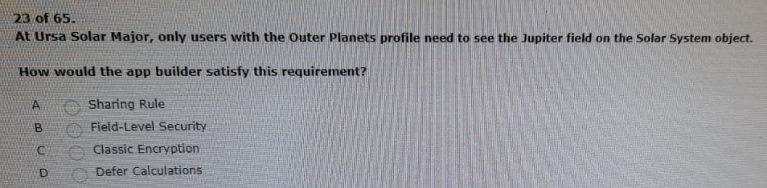
Ans: B
into the secure commitment stage to eliminate manual submission
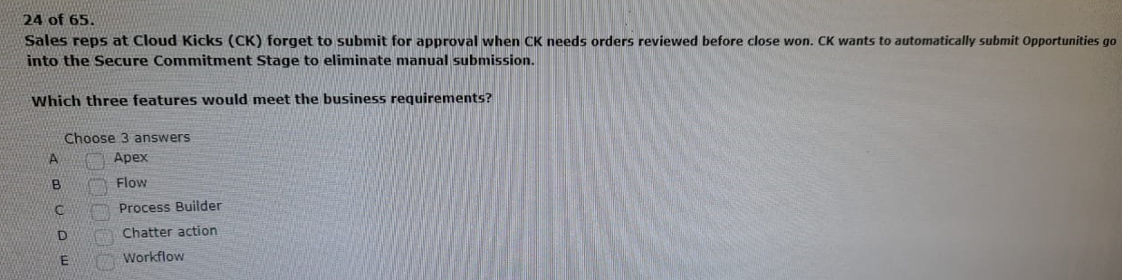
Ans: ABC

before it is allowed to enter the qualified stage
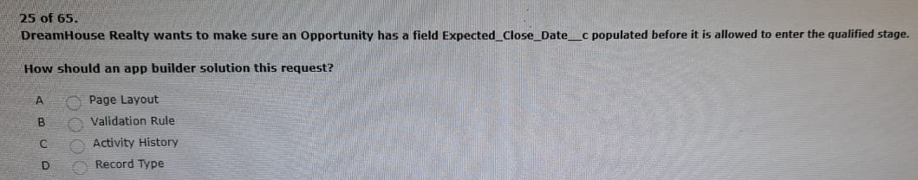
Ans: B
builder to automate some of the work being done by the sales team
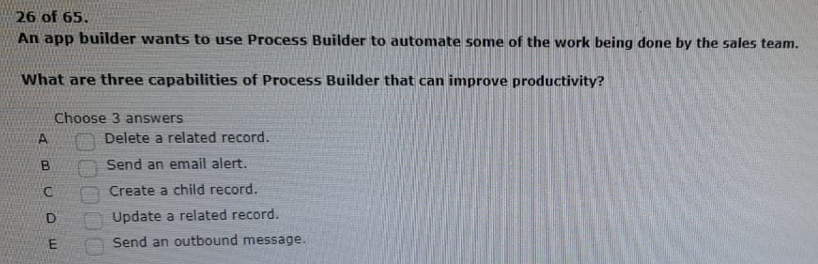
Ans: BCD
many-to-many relationships with the inventory_c and order_c objects
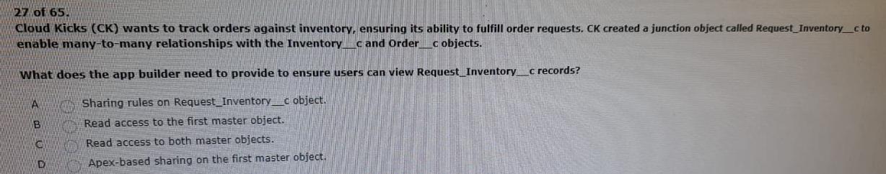
Ans: C
wants to share with the world for free via appexchange
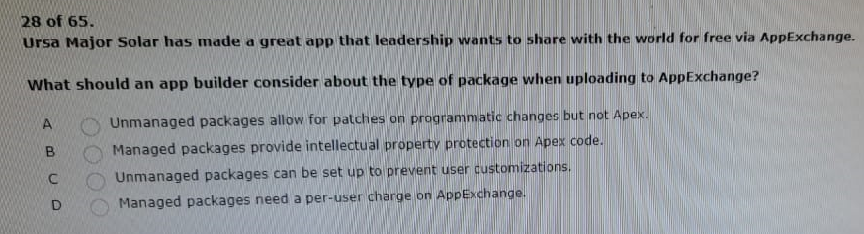
Ans: B

interest_c records if they are without read access the interest_C object
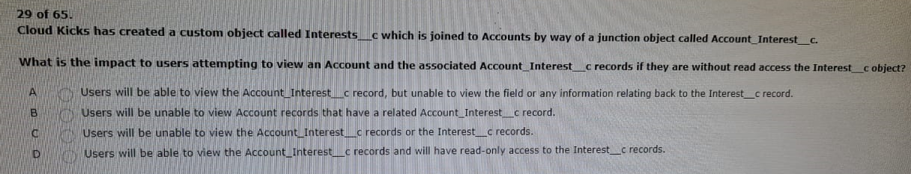
Ans: C
30 auto-populated on the asset record when a maintenance work order gets closed
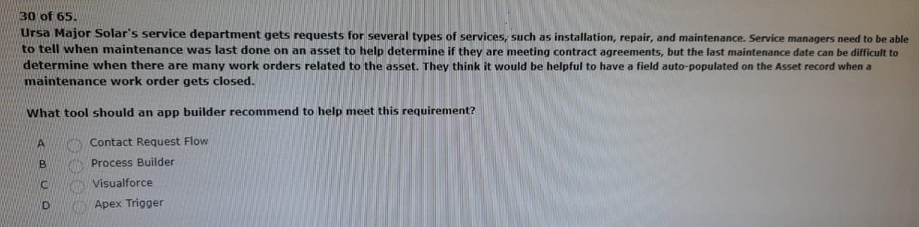
Ans: B
31.various action items based on the initial submission
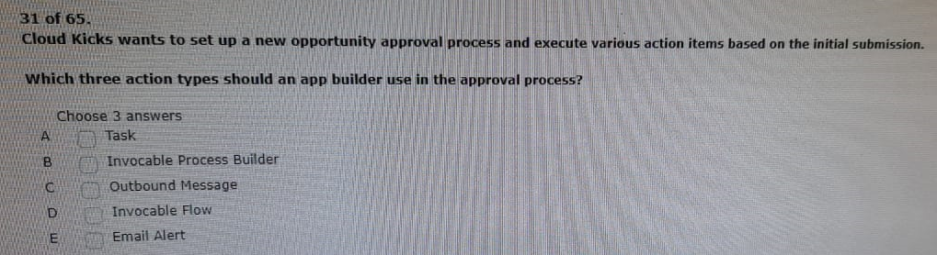
Ans: ACE
32.an account directly from an opportunity record
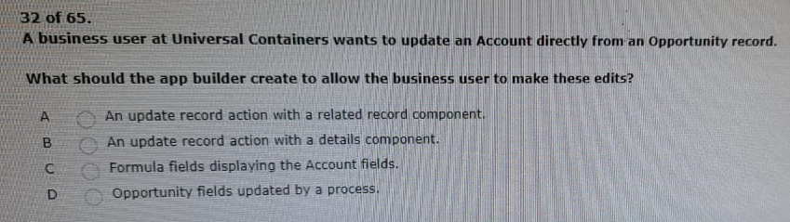
Ans: D
33.as campaign members so ck can track any future purchases the guests make
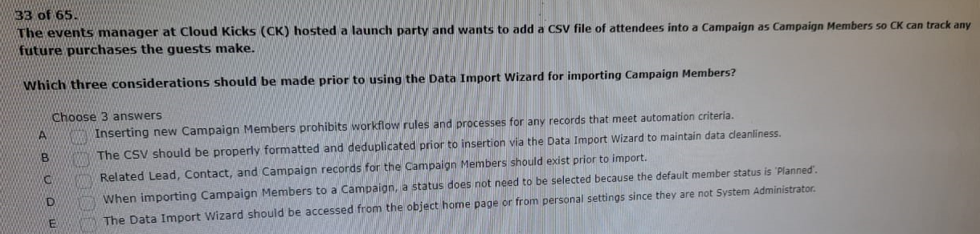
Ans: BCE
34. from the sandbox to production using change sets
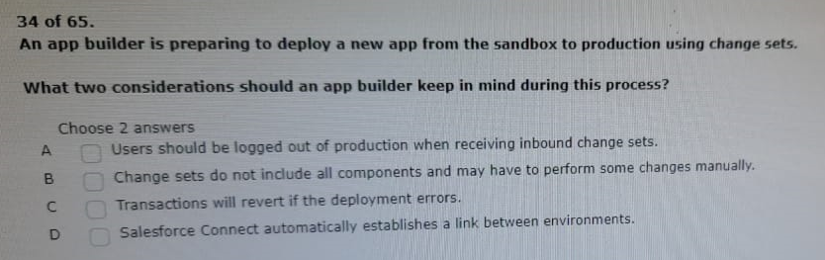
Ans: BC
35.questions via a popup window to populate additional record fields
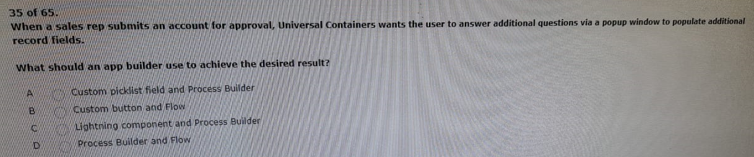
Ans: C
36.c records to each galaxy _c record
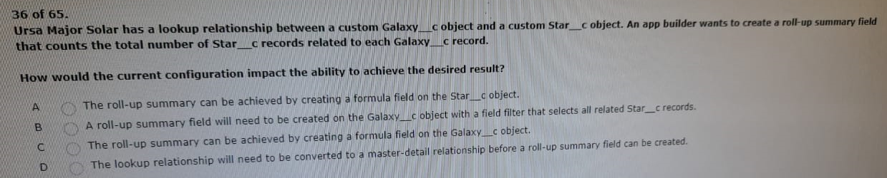
Ans: D
37.wants to make sure the team enters case priority consistently
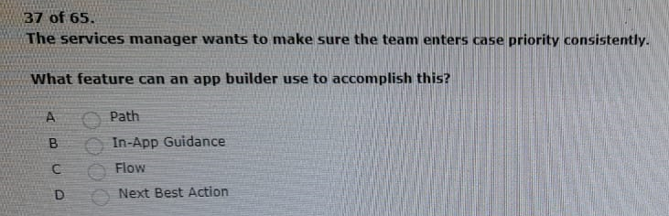
Ans: B
38. the object with fields needs to be created and the data inserted simultaneously.
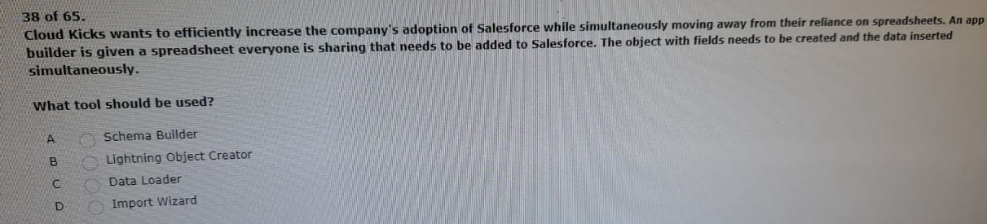
Ans: D
39.from leads, contacts, and accounts for users on mobile.
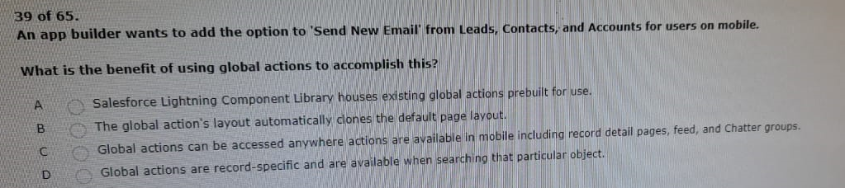
Ans: C
40.related account is a platinum-level customer.
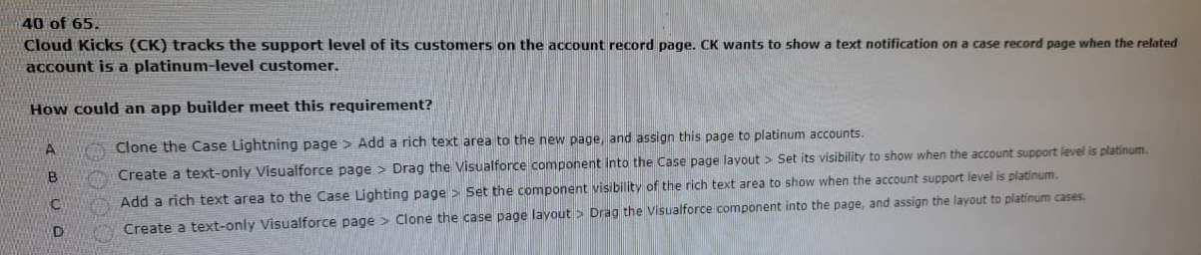
Ans: C
41.with a roll-up summary count of star_c records.
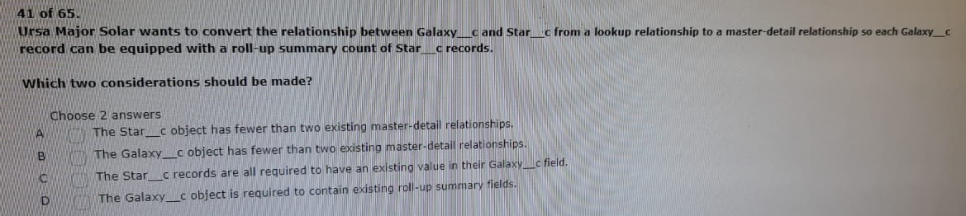
Ans: AC
42.and wants to prevent outbound email sends during testing.
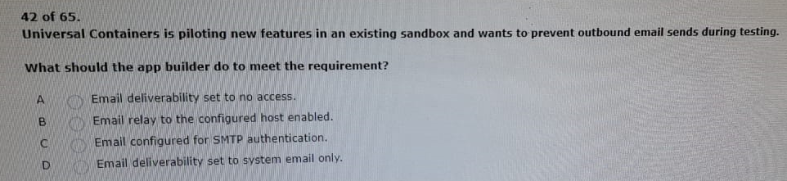
Ans: D
43.to show job applications with or without resumes.
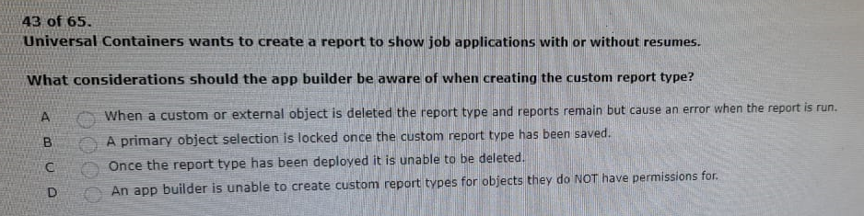
Ans: C
44.including understanding who is available to respond.
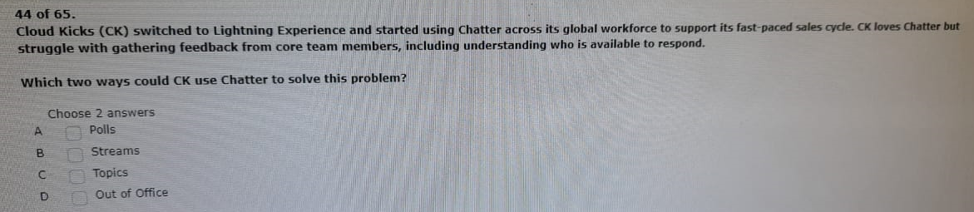
Ans: AB
45.additional permission sets that are only required for them.
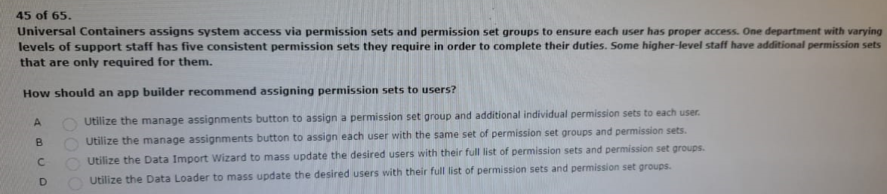
Ans: A
46.picklist fields called sales_organization_c and pricing_tier_c.
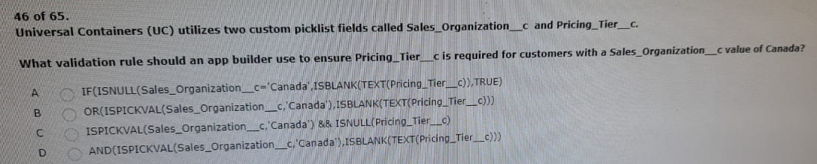
Ans: D
47.request forms to enforce the internal policy.
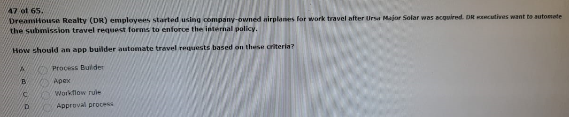
Ans: D
48.moved across any other account once it is created.
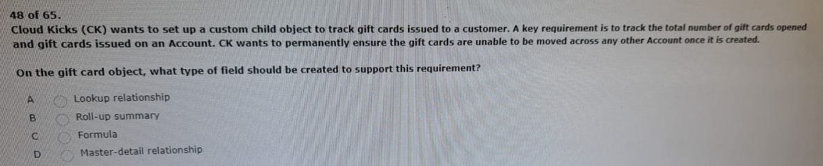
Ans: D
49.values are only supported in certain functions”.
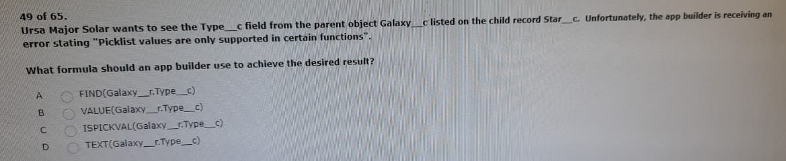
Ans: D
50.realtor they report to for a probationary period.
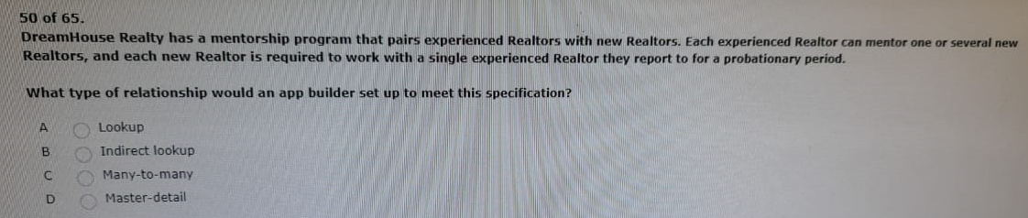
Ans: D
51.as they have been assigned the appropriate permissions.
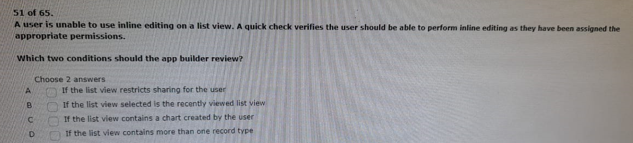
Ans: BC
52.migrate from one environment to another.
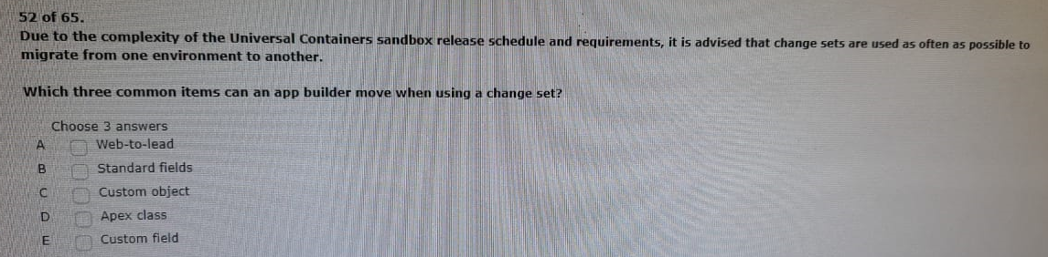
Ans: CDE
53.unable to add it to the lightning home page.
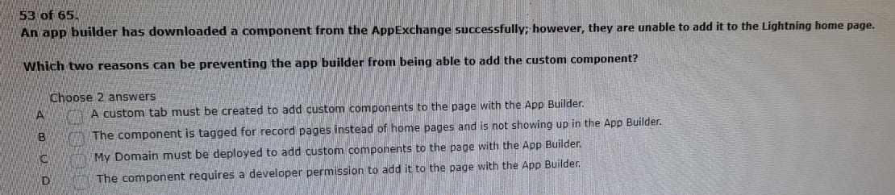
Ans: BC
54.last day of the quarter and the manager is on vacation.
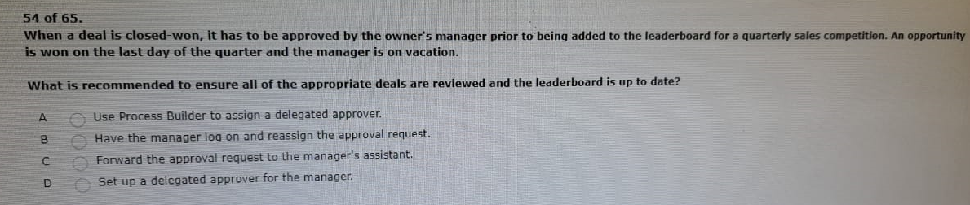
Ans: D
55.representation to track delivery status.
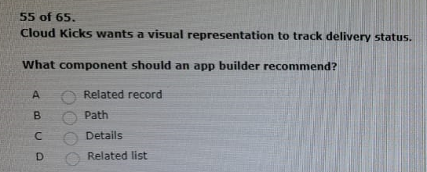
Ans: B
56.little time to build the solution from scratch.
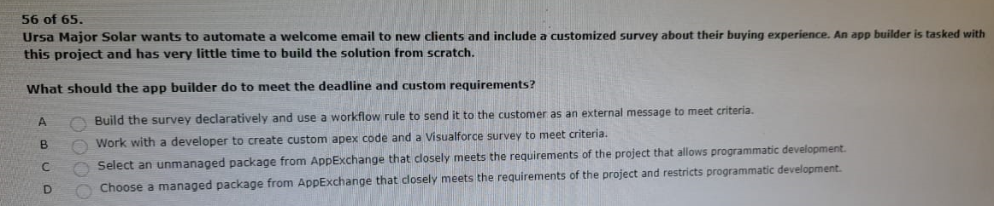
Ans: C
57.related to that account get an updated status of ‘re-market’.
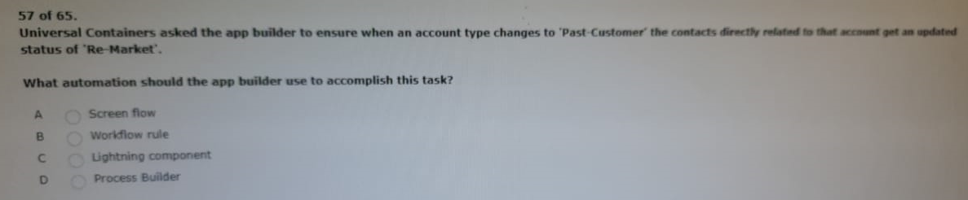
Ans: D
58.builder to create a chatter post.
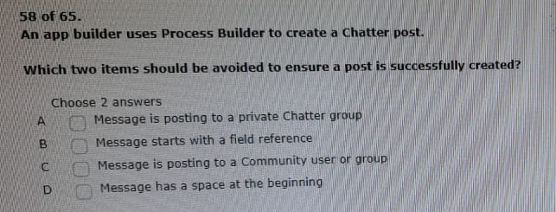
Ans: AC
59.order to ensure each record is treated uniquely.
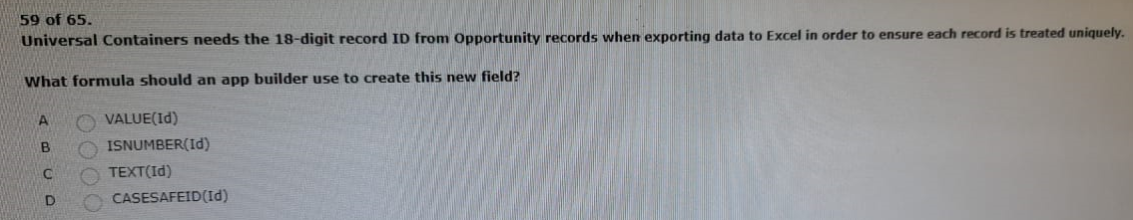
Ans: D
60.when viewing a contract related to an account.
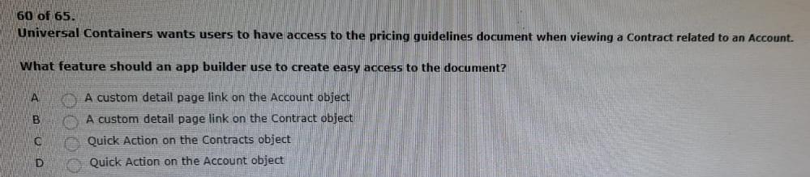
Ans: B

61.records associated with each account.
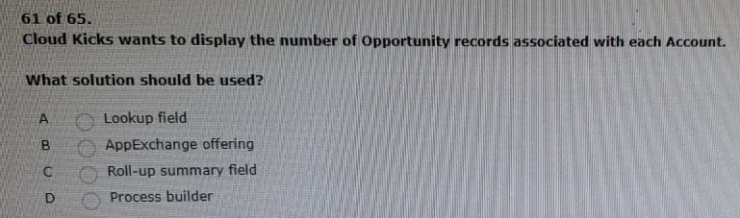
Ans: C
62,master-detail relationship but is unable to do so.
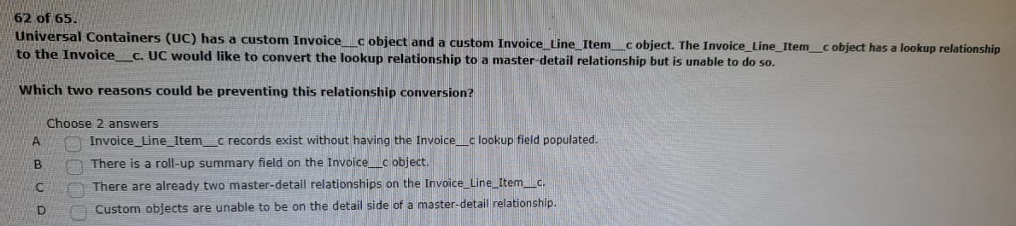
Ans: AC
63.two different objects via related lookups.
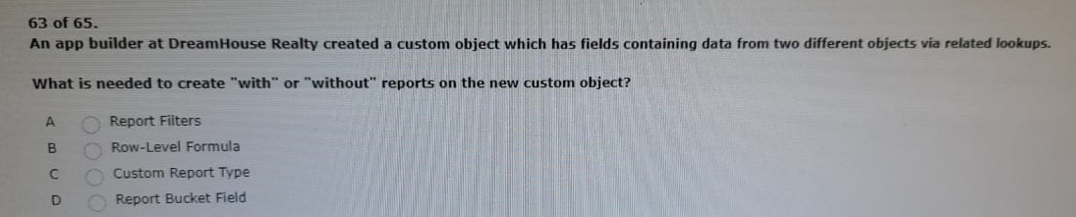
Ans: C
64.email template. This field is not required and is not always filled in.
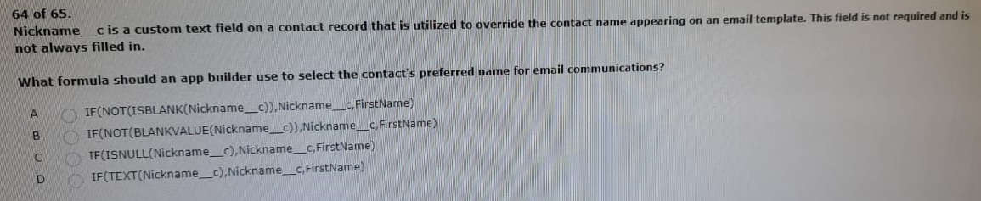
Ans: A
65. Territory management to grant access to records.
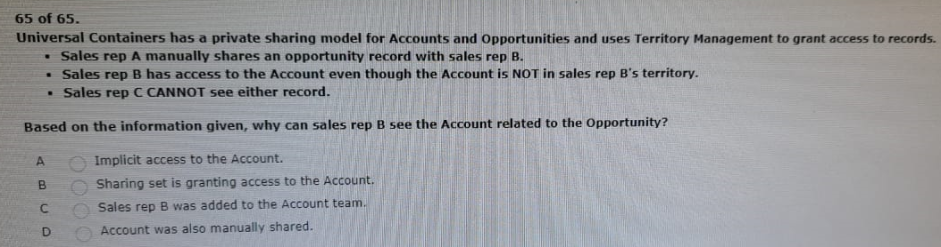
Ans: A

66.campaign members so ck can track any future purchases the guests make.
